**Innovative Renewable Technologies and their Role in Climate Change Mitigation of Rural Areas in Bihar**

***A dissertation to be submitted to***

*Central University of South Bihar*

*In fulfilment of the requirements for the degree of*

**MASTER OF SCIENCE**

*submitted by*

**RAJAK DEEPU KUMAR**

CUSB2303212020

*in*

**ENVIRONMENTAL SCIENCE**

*under the supervision of*

**Prof. Pradhan Parth Sarthi**

**Department of Environmental Science**

**School of Earth, Biological and Environmental Sciences**

**Central University of South Bihar, Gaya Ji, India - 824236**

**(2023 – 2025)**

|  |  |
| --- | --- |
|  | **दक्षिण बिहार केन्द्रीय विश्वविद्यालय**  **CENTRAL UNIVERSITY OF SOUTH BIHAR**  **NAAC accredited A++**  SH-7, Gaya Ji, Panchanpur Road, **Village**: Karhara, **Post:** Fatehpur, Gaya Ji (BIHAR),  **PIN** – 824236  **Phone/Fax** :0631-2229530 2229514, **Website**: www.cusb.ac.in |

# **Student Declaration**

I ***Rajak Deepu Kumar***, certify that work embodied in the thesis title “***Innovative Renewable Technologies and their Role in Climate Change Mitigation of Rural Areas in Bihar***” was carried out by me under the supervision of ***Prof. Pradhan Parth Sarthi***, *Head and Professor* of *Department of Environmental Science, School of Earth, Biological* and *Environmental Science*, fulfillment of the requirements for the award of **M.Sc.** Degree in **Environmental Science**. The work has not been submitted in part or full, to this or any other University or Institution, for any Degree. I declare faithfully acknowledged, given credit to and referred to the research worker wherever their works have been cited in the text and the body of thesis. I have presented my own collected data, charts and results reported from the sources both hardbound and softbound, included into my thesis and cited to my own work.

**Date:** 30.05.2025 (**Rajak Deepu Kumar)**

**Place**: Gaya Ji

**Certificate from the Supervisor**

This is to certify that the above statement made by **Mr.**  **Rajak Deepu Kumar,** a masters students conducting his research work under me during ***(July 2024 to May 2025),*** is correct to the best of my knowledge.

**Prof. Pradhan Parth Sarthi**

(Supervisor)

|  |  |
| --- | --- |
|  | **दक्षिण बिहार केन्द्रीय विश्वविद्यालय**  **CENTRAL UNIVERSITY OF SOUTH BIHAR**  **NAAC accredited A++**  SH-7, Gaya Ji, Panchanpur Road, **Village**: Karhara, **Post:** Fatehpur, Gaya Ji (BIHAR), **PIN** – 824236  **Phone/Fax** :0631-2229530 2229514, **Website**: www.cusb.ac.in |



# Certificate

This is to certify that the thesis entitled “***Innovative Renewable Technologies and their Role in Climate Change Mitigation of Rural Areas in Bihar*”** submitted by ***Rajak Deepu Kumar*** having an Enrolment No. ***CUSB2303212020***, in partial fulfilment of the requirements for the award of ***Masters of Science*** degree in ***Environmental Science*** of ***Central University of South Bihar*** has not been previously submitted for the award of any Degree or Diploma of this or any other University or Institution and it is his original work.

**Date:** 30.05.2025 **Rajak Deepu Kumar**

**Place:** Gaya Ji

|  |  |  |
| --- | --- | --- |
| **Prof. Pradhan Parth Sarthi**  *(Professor & Supervisor)* |  | **Prof. Pradhan Parth Sarthi**  *(Head, Dept. of Environmental Science)*  *Central University of South Bihar* |

|  |  |
| --- | --- |
|  | **दक्षिण बिहार केन्द्रीय विश्वविद्यालय**  **CENTRAL UNIVERSITY OF SOUTH BIHAR**  **NAAC accredited A++**  SH-7, Gaya Ji Panchanpur Road, **Village**: Karhara, **Post:** Fatehpur, Gaya Ji (BIHAR) **PIN** –824236  **Phone/Fax** :0631-2229530 2229514, **Website**: www.cusb.ac.in |

# **Copyright Transfer Certificate**

**Title of Dissertation**

***“Innovative Renewable Technologies and their Role in Climate Change Mitigation of Rural Areas in Bihar”***

**Candidate Name:** Rajak Deepu Kumar

**Enrollment Numbe**r: CUSB2303212020

**Copyright Transfer**

The undersigned hereby to the ***Central University of South Bihar*** all right under copyright that may exist in and for above thesis submitted for the award of the ***Master of Science*** in ***Environmental Science.***

***Rajak Deepu Kumar***

# **Acknowledgement**

I extend sincere gratitude to ***Prof. Pradhan Parth Sarthi (Supervisor), Dr. Sunny Kumar, Prabhat Kumar and Vikram Raj***  for their invaluable guidance and unwavering support throughout this project. Their insights significantly shaped my research. I also thank my committee members, colleagues and friends, for their thoughtful feedback. Data collections from *MNRE & BREDA* were provided my relative who were giving service in the *Ministry of India* and *Bihar Administrative Service*. Grateful help from to the staffs of Library as well *Reference Library* and *Regular Newspaper* help me in getting update with the regular research information fulfil with current data scenario.

I deeply appreciate the encouragement from my parents and teamwork capturing the level of curiosity in research developing from ***Dr. Kunal Kishore*** help me into correction into the thesis***.***

Most thankful to  ***Deepranjan Rajak, Roopranjan Rajak, Mukesh Baitha*** and as well as friends to support and helping in the fieldwork and gathering for the data collection as well improvement amendment into the final thesis.

Finally, thank you to every responder from the google survey form, your patience, understanding and endless encouragement.

**Rajak Deepu Kumar**

**M.Sc. Environmental Science**

**(2023-2025)**

# **Abstract**

In today's world, renewable energy offers a secure, long-term way to reduce our reliance on natural resources. This research focuses on developing small-scale energy solutions for communities. It explores available, small-scale renewable vitality advances, centering on piezoelectric frameworks and riverine little dam turbine establishments. These frameworks create usable vitality with negligible outside inputs and constrained asset disturbance, supporting neighborhood vitality independence and cultivating feasible improvement in rural, instructive and community segments. Country maintainability and solidness are improved through the integration of renewable innovations that, requiring as it were negligible control input, are promptly available to divisions such as farming, instruction and little businesses. Our vision is to continuously neighborhood utilities by saddling adjacent assets with small to no extra venture. The investigate strategies outlined in this study are planned to help Bihar upgrade small-scale renewable energy generation, driving reasonable and economical change in energy proficiency and generally advancement and addressing with collaboration of SDGs mission and emerging technologies model to enhance the energy productivities.

Be curious and innovative toward experimental learning in multiple paths to solve the challenges. Start to end not only one final designation but it having imaginary multivalent path in different opportunities to tackle the situation and handle the solution.

**Keywords:** *Energy harvesting, Energy Model, Piezo-electric Energy, RE (Renewable Energy), Rural Development, Socio-economics, Sustainability.*

**Table of Contents**

Student Declaration ii

Certificate iii

Copyright Transfer Certificate iv

Acknowledgement v

Abstract vi

List of Figure viii

List of Table viii

1 Introduction 1

1.1 Objectives of the Research 6

2 Review of Literature 7

2.1 Role of Public-Private Partnerships and Community Participation 11

2.2 Impact Assessment of Renewable Energy in Rural Areas 11

2.3 Challenges and Future Directions 12

3 Study Areas 13

4 Material and Methods 14

5 Results and Discussion 16

5.1 Energy Production & Consumption Statistics 16

5.2 Potential of demanded renewable sources in significant districts 24

5.3 Responder’s interaction toward to the assessment of Emerging technologies 25

5.3.1 Renewable Model development in the Rural Areas 25

6 Conclusion 32

7 Future Scope 33

8 References 35

9 Abbreviations 38

# **List of Figure**

Figure 1 - Composition of RE utilities in districts of Bihar 4

Figure 2 - Study Area (Bihar, India) 13

Figure 3 - Work Plan (Methodology) 15

Figure 4 - Variation in Cumulative RE Growth (IND) 16

Figure 5 - RE Contribution States-wise (India - 2024) 16

Figure 6 - RE Contribution Districts-wise (BREDA - 2024) 17

Figure 7 - Major states were contributions in RE Potential & growth of RE in India (APR-2025) 18

Figure 8 - Major RE Productive Districts (Bihar) with demographical indeed with Population 18

Figure 9 - Trends of total RE (INDIA) 19

Figure 10 - Composition of RE to Nation from Bihar (8%) 20

Figure 11 - RE (%) in Bihar 21

Figure 12 - RE Bihar to India shares 21

Figure 13 - Composition of RE (Bihar & India) 21

Figure 14 - Grid and off-Grid Electrification in Bihar with the Renewable technologies 21

Figure 15 - RE scope potential districts in Bihar and India (2024) 24

Figure 16 - Target green energy till SDGs mission of Bihar 24

Figure 17 - Age-Gender Participants 25

Figure 18 - Utilizing RE Model in their home 25

Figure 19 - Educational Background Categorization 25

Figure 20 - Responders Occupational scene 25

Figure 21 - Environmental modelling and Renewable energy 26

Figure 22 - Support aspects need into community 26

Figure 23 - Cost estimation or power utilities in household 26

Figure 24 - Seeking interest in Extreme Research 26

Figure 25 - Awareness to SDGs Goals 27

Figure 26 - Main sources of Energy Utilities in household 27

Figure 27 - RE trends with sustainability 27

Figure 28 - Achievement tends with SDGs goal 27

Figure 29 - ET depends on RE positive impacts to Environmental Factors 28

Figure 30 - Challenges led in ET installation 28

Figure 31 - Currently Emerging technologies working accuracy in locals 28

Figure 32 - Critical Factors impacts with an Environment 29

Figure 33 - Equity met half to targeting Achievement 29

Figure 34 - Equity met half to targeting Achievement 29

Figure 35 - Moving toward activities in Communities RE 29

Figure 36 - Sector beneficial from the RE (with All of these) 30

Figure 37 - Beneficial to the sector after initiating with RE 30

Figure 38 - E modelling aspect with addressing to Climate Changes 30

Figure 39 - Environmental consequences benefits from RE 31

Figure 40 - Renewable Energy Models Account for Environmental Costs 31

Figure 41 - Support more investment in renewable energy modelling and research 31

# **List of Table**

Table 1 - Renewable Energy Possibilities and climatic factor influencing (INDIA) 22

Table 2 - Renewable Energy Possibilities and climatic factor influencing (BIHAR) 23

Table 3 - Free generation of energy development in villages with attractive ideas 33

Table 4 - SDGs matrix to enhance the modelling of Emerging RE potential 34

# **Introduction**

Bihar is the one of the cultural states which give the high contribution in the enation growth as well as in evidence in each sector of skills, knowledge, Kings, ruler, brilliant mind peoples in our every applicable methodology. According to Ministry of Statistics data driven of demography of Bihar in high density population and demand in utilities. Total population of Bihar across 131.04 million, average household about 5.4 person, estimated household about 24.3 million and the total villages around up to 45000. Renewable vitality is getting to be progressively vital as we handle the squeezing challenges of climate alter and endeavor for a more maintainable future. Renewable energy is sourced from natural elements like sunlight, wind, water, and biomass, which are replenished over time.

India's Ministry of New and Renewable Energy (MNRE) has played a key role in promoting sustainable energy major amendment from 1980s. India has emerged as the 5th largest producer of renewable energy globally, following the United States, China, Brazil, and Canada.

According to the Central Electricity Authority’s National Electricity Plan (NEP), India’s total installed renewable power capacity is projected to reach 507,411 MW by 2031–32. Rajasthan, Gujarat, Tamil Nadu, Karnataka, and Maharashtra are the top five contributing states, significantly boosting India's global standing in renewable energy production. India has set an ambitious target of achieving 500 GW of renewable energy capacity by 2030. As of the end of 2024, the installed renewable energy capacity stands at around 210 GW. According to the Central Electricity Authority, Bihar ranks 18th among Indian states and union territories in renewable energy production. Bihar currently contributes around 7% of 787 MW from the national off-grid and grid-connected renewable energy capacity of 8,762 MW (as of 2025 estimates). The state has significant potential in solar energy, accounting for about 11.2% of the total national potential, followed by biomass, biogas, and small hydro projects. Bihar aims to be among the top 10 renewable energy producers by focusing on off-grid schemes such as street lighting, home lighting systems, solar lanterns, solar pumps, and standalone power units.

By tackling renewable energy like sun based, wind, and biomass, communities with cleaner, more dependable vitality alternatives. India’s journey in promoting renewable energy officially began in 1981 with the creation of the Department of Non-Conventional Energy Sources, marking one of the earliest steps by any country to focus on alternative energy. Recognizing its growing importance, the department was elevated to a full ministry in 1992, named the Ministry of Non-Conventional Energy Sources. To reflect a more modern and comprehensive approach, it was renamed in 2006 as the Ministry of New and Renewable Energy (MNRE). Successor to the ministry has led several transformative initiatives, such as launching the National Solar Mission in 2010, co-founding the International Solar Alliance in 2015, and introducing the Green Hydrogen Mission in 2021, all of which have helped establish India as a frontrunner in the global shift towards clean energy.

We enable country communities, making a difference them to not as it were meet their vitality needs but moreover to flourish in a changing climate. The utilities need to the production of an energy about to the total power in the world of Renewable Energy are 11% generation sources, 47.67% in India and 7% in Bihar. In the 21st century, electricity is the primary source of power for people worldwide (Statstics, 2025). Almost all households in our nation have electricity these days so that they can use energy within their homes (Kumar A. et al., 2010). India's goal of 500 GW of non-fossil fuel-based capacity by 2030 is within reach to the country's impressive 2024 progress in the renewable energy sector. India's commitment to sustainable energy transitions has been evident with a total installed capacity of 217.62 GW as of January 2025 (MNRE, 2025). The growth trajectory of solar power and wind energy in 2023 was dominated by solar power, with *Rajasthan, Gujarat, and Tamil Nadu* leading the way. Rooftop solar installations increased by 53%, while off-grid solar installations surged by 182%. The Ministry played a crucial role in policy incentives, infrastructure investments, and expanding domestic manufacturing in solar PV and wind turbines.

**Total Energy Peak (*met-demand)* = $(\frac{peak met}{peak demand}*100$)**

Peak demand and peak met are the cross sectional between the composition between the generation of electricity on field. As per data sources from the *IREDA and BREDA*, peak demand of India and Bihar are approximate up to 233 GW and 6.5 GW, where the Bihar met contribution about to 2.79%, and it peak met of India and Bihar are approximate up to 229 GW and 6 GW which can contributes about to 2.62%. Peak demand state the total affinity of the generation of the electricity and peak met how much energy getting actual for using and better for the percentage ratio. Another peak demand-met ratio of India and Bihar are approximate up to 98.29% and 92.31% are respectively. India faces financing limitations and technical challenges in deploying renewable energy, despite being a global leader in climate change mitigation. To address these issues, India should focus on sustainability and renewable energy production, utilizing small-scale tools. Rural communities significantly contribute to social and environmental resilience, tackling challenges like climate change, thereby promoting sustainable development (Halsnaes, 2007). Interconnected issues such as socioeconomic instability and resource degradation are interconnected and require innovative solutions to address these challenges effectively (Maithai, 2023). Renewable energy technologies, such as solar panels, wind turbines, bioenergy systems, and small hydro setups, have been utilized to drive socio-economic change in rural areas (Kumar S, 2024).

Low estimation of technologies is causing a decline in their effectiveness, yet they are transforming the way we live and work (Karjalainen et al., 2014). SPSS utilizes technologies to analyze energy use, socioeconomic effects, and trends in rural regions, promoting energy independence, efficiency, and economic growth through regression analysis (Owusu & Asumadu-Sarkodie, 2016). Successful integration of renewable technologies in rural energy systems is hindered by systemic barriers like high installation costs, inadequate infrastructure, and insufficient policy support (Owusu & Asumadu-Sarkodie, 2016). Renewable technologies are being utilized to tackle resource-dependent economies' challenges like changing precipitation patterns, declining agricultural productivity, and natural disasters, promoting sustainable, self-reliant futures. Renewable energy technologies are developed to address the unique challenges faced by rural communities, offering distinct benefits and limitations (Piippo & Pongrácz, 2020). Solar micro-grid lighting up an entire village, ensuring every home enjoys clean and steady energy (Imai & Palit, 2014). Sustainable power solutions improve daily life and adapt to community needs, but require significant upfront investment, especially for rural communities with limited financial resources. Agricultural residues can be transformed into valuable resources through biomass energy plants, transforming waste into electricity and fuel.

Wind energy, despite challenges, offers low operational costs and supports rural development (Behera, 2011). Energy systems play a crucial role in maintaining work during off-peak hours, detecting power shortages, and ensuring efficient operation, with local communities receiving training and education to optimize these systems (Schuetz et al., 2017).

Emerging renewable technologies are being integrated in rural areas, significant steps achieving development climate resilience (Piippo & Pongrácz, 2020). Enhancing rural quality of life and safeguarding ecosystems (Simões et al., 2022). SPSS is a powerful tool for data analytics, enabling the exploration of human-centric solutions and renewable technology solutions. Its integration with local knowledge ensures that innovative approaches align with community needs and priorities (Clausen & Rudolph, 2020). A holistic approach to environmental sustainability is being implemented at the grassroots level, fostering engagement and enhancing economic opportunities while promoting environmental sustainability (Dhayal et al., 2024). The aim is to contribute to a framework that policymakers can use for effective rural development (J & Majid, 2020).

Bihar, India's second-largest populated state, faces challenges in energy development due to its large population and lack of renewable energy sources like solar, wind, hydroelectric, geothermal, and biomass (Huck, 2022). Technological advancements have revolutionized energy systems, enhancing efficiency, cost-effectiveness, and job opportunities in renewable energy sources (Imai & Palit, 2014). The SDGs aim to protect the environment, combat climate change, eradicate poverty, and ensure a high quality of life for all (Huck, 2022). Renewable technologies offer a sustainable alternative to fossil fuels, providing electricity to underserved areas and promoting energy independence, thereby fostering a more equitable future ( Pathak; Deshkar, 2023). Lack of natural resources has an effect on energy generation capacity and contribution weightage, which lowers net growth slightly and required technical and model improvement. The increasing population and constant natural resources on our planet have led to competition in products and challenges for people's utilities (Zahra et al., 2021). Renewable energy sources in real life have significant environmental significance, enhancing human life comfort and productivity, whenever transitioning to renewable utilities may lead to settling, despite potential benefits. Our nation heavily relies on global producers for limited resources, leading to significant imports and economic defects. However, this is beneficial for utility and maintaining balance (Garba Danjumma Sani, 2019). Renewable sand sustainable processes are long-term, reproducible, and accessible through reliable energy harvesting, requiring minimal investment and multiple integrated upgrades. *IREDA* ranks India 4th in renewable energy generation, promoting sustainable livelihoods in rural areas by reducing dependency on imported resources and enhancing productivity, thereby fostering ecological stability and economic development(Adolph, 2024). India's major focus is on sustainable energy, particularly in Bihar, which generates 7% of the nation's total energy. The government is implementing initiatives like the *National Green Hydrogen Mission, PM-KUSUM, and PLI Scheme* to reduce reliance on fossil fuels and promote sustainable energy (Bhide, 2011).

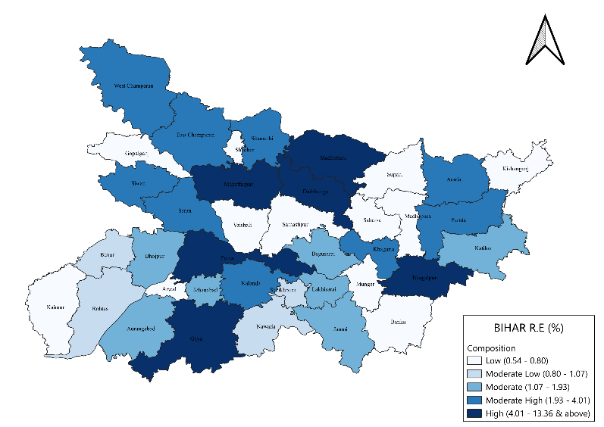

Figure 1 - Composition of RE utilities in districts of Bihar

Bihar is actively working to enhance its potential in renewable energy, contributing to the SDGs goal by reducing conventional energy usage and reducing its impact on the environment, despite lagging behind India's 22-25% share (Kumar A. et al., 2010). Renewable energy sources offer sustainability but have potential environmental impacts, including land degradation, marine ecosystem disruption, hydropower risks, geothermal emissions, bioenergy producing greenhouse gases, and ocean energy equipment harming marine life (Owusu & Asumadu-Sarkodie, 2016). The alternative mechanism, or free hand, aims to explore sustainable utilities by examining risks and utilizing SWOT analysis to explore quality, durability, and compatibility with existing systems (Karjalainen et al., 2014; Smith et al., 2018). Regional centre is fostering innovation processes and change among communities, enhancing their capacity to handle climate change risks and promoting green energy use. This initiative aims to find smart, affordable solutions for local challenges ( Kabiraj; Singhal, 2023).

Renewable energy between India and Bihar highlights distinct stages of transformation, underscoring both progress and potential (BREDA, 2017). Globally, about 26%–30% of power is generated from renewables, reflecting an accelerating shift toward cleaner energy supported by technological advances and evolving policies. India has significantly amplified its renewable capacity to roughly 40%–45%, driven by national initiatives and expansive solar and wind projects that are reshaping its energy landscape. Bihar's renewables, contempt their low share of 8%-10%, show potential for growth due to its solar potential and emerging policy measures (Behera, 2011; Imai & Palit, 2014). India and Bihar are undergoing transformative change, contributing to the global quest for energy sustainability, demonstrating rapid progress in securing a sustainable future (Maithai, 2023). *SPSS Analysis, AI and ML, R Studio and QGIS* are utilized to analyze data from progressive Indian and Bihar states, examining factors affecting living conditions and their impacts. This data is visualized and analysed for comprehensive assessment. India's renewable energy landscape is dominated by solar energy, accounting for 35% of the renewable mix, with ***Rajasthan and Gujarat*** leading the way with extensive photovoltaic installations (Adolph, 2024). Clean energy projects harness abundant sunlight, reducing fossil fuel reliance and promoting climate action, aligning with SDG 7 and SDG 13 by ensuring access to renewable power (Razmjoo et al., 2020) and (Maithai, 2023).

***Tamil Nadu and Maharashtra,*** two states in India, significantly contribute to the renewable mix, with wind energy accounting for 40% of the country's renewable share. This energy source supports SDG 9 by promoting sustainable industrial growth. ***Himachal Pradesh and Uttarakhand*** have made significant contributions to India's renewable energy sector, utilizing their river systems for electricity generation. Hydropower projects significantly reduce carbon emissions and preserve ecosystems, aligning with SDG 6 (Clean Water and Sanitation) and SDG 15 (Life on Land) by supporting water resource management. Biomass and biogas form about *5%* of India's renewable energy mix, prominently in regions like ***Punjab and Haryana***. Responsible consumption and decent work are crucial for economic growth and responsible consumption, as demonstrated by projects converting agricultural residues into renewable energy, reducing methane emissions. ***Patna, Muzaffarpur, and Bhagalpur*** are thriving in solar energy projects, utilizing Bihar's high solar insolation to generate 70% of the state's renewable energy mix (Sharma, 2023). Solar energy is being prioritized in climate action to combat climate change, reducing reliance on fossil fuels and promoting sustainable development aligns with SDG 7 and SDG 13.

Biomass and biogas contribute around *25%* to Bihar’s renewable range, with notable projects in districts like ***Begusarai, Nalanda and Vaishali***. Biomass projects promote responsible consumption by utilizing agricultural residues and organic waste for energy, reducing environmental impact and providing a reliable, carbon-neutral energy source, aligning with SDG 12 and SDG 8. Small-scale hydro projects, constituting about *5%* of Bihar’s renewable energy, are primarily concentrated in regions like ***Bhagalpur*** and ***Munger***. SDG projects infrastructure development by utilizing natural flow of rivers, enriching local energy infrastructure and contributing to environmental benefits and regional development ( Kabiraj; Singhal, 2023). Bihar is embracing renewable energy sources, including wind energy, to combat climate change and ensure a sustainable future in the world (Schuetz et al., 2017).

Investigating renewable technologies in rural Bihar is crucial for a sustainable future. Bihar is actively promoting renewable energy and sustainable development through various initiatives, focusing on enhancing energy usage habits and evaluating the adaptability and accessibility of various technologies. Solar power has seen significant expansion, with 2,589 rooftop solar units generating 22 MW, alongside floating solar projects in *Supaul and Darbhanga*. Hydropower also plays a crucial role, with 13 operational mini hydro projects producing 54.3 MW, with more in the pipeline under the Bihar State Hydroelectric Power Corporation (BSHPC).

***Shyama Prasad Rurban Mission*** and the ***Mukhyamantri Gramin Solar Street Light Yojana*** are aimed at enriching rural infrastructure and ensuring sustainable energy access, reinforcing Bihar’s commitment to a greener future (Clausen & Rudolph, 2020).

## Objectives of the Research

* To assess the current status and adoption of renewable energy in rural districts of Bihar.
* To identify the potential for emerging sustainable renewable energy technologies in different districts with geographical and demographical, assessing impacts and strength.
* To analyze the feasibility and effectiveness of emerging technologies in addressing climate challenges sustainably.
* To align renewable energy initiatives with SDGs. Major focus on SDG 7 (Affordable and Clean Energy) and SDG 13 (Climate Actions).

# **Review of Literature**

Renewable energy sources like sunlight, wind, and biomass are becoming increasingly sustainable and environmentally friendly. With new technologies and improved energy storage systems, renewable energy is becoming more accessible and appealing globally. Challenges like intermittent energy production and significant initial investment persist, but positive technology trends, policy support, and cost reductions indicate a cleaner, more sustainable energy future (Bhide, 2011). Renewable energy is crucial for achieving the Sustainable Development Goals (SDGs), promoting health, economic growth, and combating climate change. Limited infrastructure and weak policy hinder progress in renewable energy access, requiring collective efforts, investments, and innovative solutions to revolutionize rural areas and improve lives. Regional solutions offering education, health, and economic opportunities involve solar mini-grids and small hydro plants, which power homes, schools, clinics, including business (Imai & Palit, 2014). Project success in India is attributed to its commitment to renewable energy, which not only reduces greenhouse gas emissions but also strengthens community resilience, making it a significant player in the global renewable energy landscape (IRENA, 2025). India is the world's 3rd largest consumer of electricity and the world's 3rd largest renewable energy producer with 46.3% of energy capacity installed as of October 2024 (203.18 GW of 452.69 GW) coming from renewable sources. Bihar is aiming to improve its green energy performance and become one of the top 10 states by 2030, focusing on expanding solar and biomass energy (BREDA, 2024).  Global dependence on finite fossil fuels like coal, petroleum, and natural gas causes significant ecological harm, increasing extraction costs and challenges, and perpetuating environmental degradation (Grimoldi, 2018). Imagine living in a village where electricity is a comfort zone, causing darkness, student struggles, and business efficiency issues. Transitioning to renewable energy promotes economic stability. Exploring green energy reveals ecological benefits, economic impacts and business opportunities (Venkatakrishnan et al., 2020). A small startup in Bihar is implementing sustainable solutions to boost its energy harvesting capabilities, demonstrating the importance of community engagement in achieving environmental sustainability (Eqra, 2018).  By supplying clean, sustainable energy, renewable energy technologies like powered by sunshine microgrids and biogas plants are transforming communities (Eqra, 2018). The integration of advanced technology like robots and AI with traditional systems, contempt its early stages, presents both potential efficiency benefits and potential job displacement risks (Kumari, 2023).

Research on rural development progression and renewable energy system design is crucial, especially in Bihar's developing regions (Kumar S, 2021). The energy which can be regenerating independently without guessing of time luggage. The probability of continuous and effecting with the leading with sustainability and without causing linkage barrier to the individuals. We conducted a survey to gather baseline data and engage with locals to understand their household utilities and challenges. Renewable energy refers to energy derived from natural sources such as the sun, wind and biomass that can be replenished over time (Kumar A. et al., 2022). Health clinics in rural areas are utilizing renewable energy solutions to reduce their reliance on unreliable grid power. India's overpowering dependence on conventional fuels makes Bihar, a state with an abundance of solar and biomass resources, an excellent choice for decentralized energy solutions (BREDA, 2024). Renewable management significantly reduces poverty by creating jobs in energy management, installation, and maintenance, while also combating climate change by reducing carbon emissions (CEA, 2011).

India's significant progress in renewable energy has transformed from small-scale initiatives to becoming a global leader in clean energy. In 1982, Indira Gandhi established the Ministry of Non-Conventional Energy Sources (MNES) to explore alternative energy solutions. The IREDA, under the leadership of P. V. Narasimha Rao, initiated India's first renewable energy program in 1992, paving the way for a cleaner future (Adolph, 2024) and (Imai & Palit, 2014).

Atal Bihari Vajpayee significantly influenced India's Electricity Act of 2003, promoting renewable energy as a key component of state power planning and enabling private companies to invest in clean energy. The momentum continued under *Manmohan Singh,* who launched the *National Action Plan on Climate Change (NAPCC) in 2008.* he National Solar Mission, in collaboration with the Renewable Energy Certificate (REC) Mechanism, aims to promote sustainability by facilitating large-scale solar energy adoption and promoting green energy trade. Under Narendra Modi, India has significantly increased its focus on clean energy, renaming MNES to the Ministry of New and Renewable Energy (MNRE). India launched the International Solar Alliance (ISA) in 2015 and the FAME scheme (2017) to promote electric vehicles and reduce dependence on fossil fuels. The PM-KUSUM scheme aims to install solar-powered irrigation systems, supporting farmers and achieving India's target of 500 GW of renewable energy capacity by 2030(Energy, 2024). In 2023, the Indian government launched the National Green Hydrogen Mission to establish India as a global hub for green hydrogen production. Rapid advancements in solar energy are paving self-reliant future, demonstrating the transitioning to clean energy sources for a sustainable future( Pathak; Deshkar, 2023)*.* The unique challenges faced by Bihar in gaining traction for renewable energy exploration are a significant factor in the country's progress, as the region faces distinct challenges that necessitate localized solutions to effectively harness the potential of renewable energy. Examine the importance of renewable energy in rural development (Smith et al., 2018). Identify key drivers and barriers to renewable energy adoption (Kumar A. et al., 2010). A bibliometric reviewing these technologies effects on the environment and society. Assess the role that renewable energy plays in reducing the effects of climate change (Mishra, 2024).

Summarize any potential strategies for developing Bihar's renewable energy production. This analysis seeks to provide light on how Bihar could employ renewable innovation for a more resilient and clean future by examining current studies and case studies. A variety of the advancements in the use of renewable energy, there are still a number of policy and research implementation gaps, in particular in Bihar (Bhide, 2011). Climatic addressing the social, economic, and environmental advantages for improving communities, the research attempts to evaluate and investigate new prospects for small-scale energy generation, enabling its growth into large-scale production (Patil et al., 2024) and (Piippo & Pongrácz, 2020). The unique socio-economic and environmental challenges faced by Bihar, a region with limited localized data, are often overlooked in studies focusing on India as a whole. The integration of traditional and modern systems is a complex issue that requires further exploration to fully understand how modern renewable technologies can enhance traditional energy practices (Kumar A. et al., 2010).Research on effective community engagement strategies for rural communities is limited, contempt the existence of large-scale projects.Numerous studies highlight the economic benefits of renewable energy, but few provide solutions for financial constraints, subsidy inefficiencies, and regulatory hurdles in Bihar (Karjalainen et al., 2014). Renewable energy's role in mitigating Bihar's vulnerability to extreme weather events is not fully understood due to energy and fuel cell technology shortages in India flyer to climatic resilience (Mishra, 2024).

The assessment of renewable energy adoption in rural Bihar and India is based on various factors. The study aims to identify the key factors that influence the success and limitations of renewable energy projects. The study aims to assess the socio-economic and environmental effects of renewable technologies. The study delves into the potential of renewable energy in mitigating climate change and enriching resilience to extreme weather events (Pathak & Deshkar, 2023). Provide for future research and policy development.

Renewable energy adoption in rural areas is crucial for communities, especially when small models are installed to produce energy. Rural India, particularly in states like Bihar, is experiencing a significant lack of access to reliable electricity (S. Kumar, 2021). By supplying vital power for cooking, lighting, and other productive tasks, renewable energy solutions like solar mini-grids and household systems improve the standard of living and economic opportunities in off-grid communities (Behera, 2011). Renewable energy options like *solar mini-grids* and standalone *solar home systems (SHS)* offer an environmentally friendly solution in Bihar, where a significant proportion of the rural populace lacks consistent access to electricity (Kabiraj; Singhal, 2023). These technologies enhance the use of electric irrigation systems in agriculture, improve living conditions in households, and make improved healthcare services possible, all of which increase income and production. Renewable energy uptake in developing rural areas is influenced by a number of factors.

**Economic Feasibility**: Rural households could currently afford solar panels, battery storage, and other renewable technology due to their declining costs. Financial barriers are further reduced by government subsidies and microfinance programs (Zahra et al., 2021).

**Government Policies**: Investment in rooftop solar, wind, and biomass energy projects is encouraged by national and state laws in India, which include Bihar's Renewable Energy Policy. Tax breaks and capital subsidies are examples of incentives that promote private sector activity (Government, 2020; Jebaraj & Iniyan, 2006).

**Technological Awareness**: Increased acceptance and uptake of renewable technologies in rural communities has been largely attributed to awareness campaigns and capacity-building initiatives (Abdelaziz et al., 2018; Imai & Palit, 2014).

**Adoption of Renewable Energy faces Significant challenges considering its Capacity.**

* **High Initial Costs**: Indeed, with low expenses for operation, low-income households still find it difficult to make the initial investment in solar panels and hybrid energy systems.
* **Infrastructure Limitations**: The infrastructure required to develop and operate renewable energy systems is lacking in many isolated settlements.
* **Policy and Regulatory Barriers**: Project execution is slowed down by inefficient organization and a lack of clarified laws and regulations.
* **Community Resistance and Awareness Gaps**: Adoption can frequently be delayed by assumptions and a lack of knowledge of technology among rural populations.
* **Climate Risks and Extreme Weather Events**: Bihar is particularly vulnerable to droughts and floods, which can harm the infrastructure supporting renewable energy.

Renewable energy implementation strategies in rural places where the sources supply dependable electricity to locations that are far away.These mini-grids, which often are operated by privately owned businesses working with government agencies, guarantee a steady supply of electricity to residences, colleges and universities, and small-scale businesses (Grimoldi, 2018; Imai & Palit, 2014). *Photovoltaic panels, battery storage, and LED lights make up solar home systems*, which have become a popular way to electrify individual homes. They decrease demand on engines and kerosene through offering inexpensive, low-maintenance energy access (Energy, 2024). In the sustainable environment, hybrid energy systems that integrate sun, wind, and biomass sources provide increased reliability and effectiveness for human-powered green energy production. They guarantee a steady supply of electricity by assisting in reducing the problems related to single-source renewable energy systems (Himabindu et al., 2024).

## Role of Public-Private Partnerships and Community Participation

Governments, commercial companies, and local communities must work together to achieve the desired permissions for the adoption of renewable energy. Public-private partnerships (PPPs) have the potential to enhance service delivery, draw in investment, and ease the transfer of technologies. Cooperative approaches of community engagement guarantee ongoing viability and ownership in the community.

## Impact Assessment of Renewable Energy in Rural Areas

***Social Impact: Quality of Life, Education, Healthcare***

Children can study for longer periods of time and achieve better educational results when there is better illumination. Reliable energy helps rural health care facilities operate medical equipment and store vaccines more effectively renewable energy lessens domestic chores and permits businesses to generate income, the empowerment of women rises (Imai & Palit, 2014).

***Economic Impact: Job Creation, Income Generation, Poverty Reduction***

Renewable projects are fostering local manufacturing, promoting stability and lowering energy prices, thereby reducing household expenses and enriching overall economic growth (Kumar S, 2021; Zahra et al., 2021).

***Environmental Impact: Reduction in Deforestation and Greenhouse Gas Emissions***

Transitioning to renewable energy sources, such as biomass and fossil fuels, is crucial for reducing deforestation, air pollution, and carbon emissions, contributing to climate change mitigation (Grimoldi, 2018; Odoi-Yorke et al., 2022).

***Addressing Climate Change Through Renewable Energy***

The transition to renewable energy sources is a crucial step towards reducing greenhouse gas emissions and achieving India's climate goals under the Paris Agreement (IRENA, 2025).

***Climate-Resilient Technologies***

Renewable energy systems are becoming more reliable in flood-prone regions like Bihar, thanks to advancements in energy storage, smart grids, and disaster-resilient infrastructure.

The case studies illustrate how localized renewable energy initiatives, such as solar-powered irrigation systems and community microgrids, effectively promote climate change mitigation by reducing emissions, enriching water efficiency, and strengthening resilience in rural communities (Dhayal et al., 2024). These examples demonstrate practical, scalable strategies that empower local populations to adapt sustainably to climate challenges while advancing environmental goals.

## Challenges and Future Directions

Combining contemporary renewable energy technology with conventional systems to increase their adoption in rural areas as pointing out important gaps in statistical data and regional rules and regulations. Like-wise it talks about the obstacles to financial investment and points out that impact assessments and socioeconomic surveys are usually vacant when assessing renewable energy projects.

Plenty people and communities face economic hurdles when trying to access clean energy solutions. Finding ways to make financing easier, like cost-effective solar systems, can help more families afford these technologies, policy side, clearer rules and simpler regulations are needed on encourage private companies to invest confidently, making it quicker and easier to roll out sustainable displays and bring cleaner energy to more people (Bhide, 2011).

One of the main challenges in expanding renewable energy is ensuring we have enough skilled workers to install and maintain the systems properly. Investing in technical training programs can help create a workforce that’s confident and capable, making the transition smoother and more reliable. For Bihar’s rural communities, embracing renewable energy about cleaner power and it is a real chance to boost development and create better opportunities for local people while also helping fight climate change.

Rural communities are benefiting from the renewable energy sources like solar, wind, and biogas, providing stable electricity and reducing reliance on fossil fuels. Sustainable gadgets like solar-powered lights and cooking devices offer safer, affordable, and environmentally friendly energy options in an environmental field (Kumar S, 2021).

Policymakers need to focus on making renewable energy more accessible and appealing. This means offering financial help like subsidies, building better infrastructure, and involving local communities in the process (Goel & Rath, 2022). Providing clear rules and practical support can encourage more people and businesses to choose clean energy solutions, helping everyone benefit from a greener, healthier future. Looking ahead, research should explore new ways to make renewable energy more affordable through creative financing options focus on combining different types of energy systems to boost their efficiency and find local solutions that help vulnerable communities adapt better to climate challenges. We can create more sustainable, resilient futures tailored to the needs of different communities (Himabindu et al., 2024; Reghunadh, 2016). Bihar is focusing on improving infrastructure and energy, aiming to become a leader in sustainable growth (Accone & Lui, 2023). By making renewable energy more affordable, supporting local communities, and enriching infrastructure, the state can provide cleaner, reliable energy for generations to come (Adolph, 2024; BREDA, 2024).

# **Study Areas**

The area considered for examine for my research the place was the highly and denser and what shall we prefer to do our best and led factor to enriching the better evidence in the locality to promote the development into the urban and rural development with energy potential modelling enriching for the live hood to the people who were staying and keep their attributes to keeping long term probabilities to hold the growth in development. The study examines how renewable innovations in rural Bihar contribute to addressing climate change challenges, particularly in relation to extreme weather events (Dhayal et al., 2024).

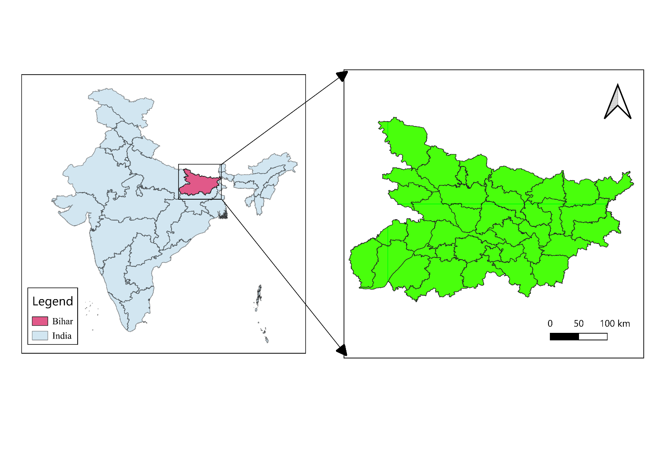

Figure 2 - Study Area (Bihar, India)

This study focuses on specific districts in Bihar that demonstrate significant potential for advancing renewable energy development. The chosen district is identified as capable of adopting and integrating renewable energy, while the evaluation of extreme weather events aims to assess opportunities for long term capacity savings and energy storage. Compiling with Sustainable Development Goals (SDGs) indicators for development and performance in Bihar with regional, national, and international benchmarks from the time the SDGs were first adopted. We will investigate how renewable energy initiatives in selected districts can promote rural development by identifying opportunities, tackling challenges, and exploring sustainable growth strategies. Our analysis focuses on tools like *SPSS, ANOVA, RStudio, and MS Excel* for our analysis. Human demographics and geographical factors affecting the areas, assessing extreme weather events influenced by climate factors, evaluating the efficiency of renewable energy models, and categorizing and analyzing the available development schemes in Bihar.

# **Material and Methods**

The MNRE and UNDP are collaborating to analyze renewable energy adoption in rural Bihar. The study uses international, national, and regional data sources to understand best practices, *Sustainable Development Goals, and MDGs.* The *MNRE and UNEP* will evaluate progress and identify challenges for improvement.

Data collection, both primary and secondary methods will be employed. A structured survey will be conducted using questionnaires to gather information from rural communities, policymakers, and renewable energy stakeholders. Questionnaire assesses awareness, perceptions, and challenges with review of research and data analyses tracks renewable energy trends and SDG progress.

Statistical analysis will be used to interpret data on renewable energy adoption levels across Bihar regions. *SPSS and ANOVA* will be used for efficient processing. Descriptive analysis will summarize survey findings, while hypothesis testing will examine relationships between variables like government incentives and renewable energy awareness.

Data visualization and management, QGIS (Geospatial Analysis) will be employed to map renewable energy adoption across Bihar at the district and village levels. This will help visualize the spatial distribution of renewable energy projects and highlight areas with high potential for further expansion. Microsoft Excel will be used for organizing large datasets, conducting cost-benefit analyses, and tracking renewable energy capacity trends.

NITI Aayog is utilizing various online platforms to collect secondary data on renewable energy policies, implementation strategies, and adoption rates, assessing electrification levels and energy accessibility in rural Bihar districts.

The study aims to formulate questions about renewable energy adoption, technological advancements, and climate resilience through a structured approach, involving literature review, data collection, and analysis. The findings are refined into a thesis, recommending practical policies for sustainable energy adoption.

The survey explores the impact of renewable energy technologies on rural areas, particularly in the context of climate change. It assesses demographic data, environmental modelling, and renewable energy sources. The survey also explores current energy sources, support mechanisms, and utilization of renewable energy technologies. Challenges include high initial costs, technological limitations, infrastructure deficits, and policy issues. The results aim to inform strategies for increasing renewable energy deployment for rural development and environmental sustainability.

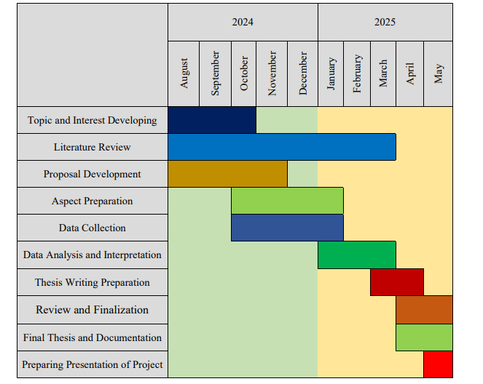

Figure 3 - Work Plan (Methodology)

The research project follows a structured timeline from August 2024 to May 2025, beginning with topic and interest development (August–September 2024), followed by an extensive literature review (September 2024–January 2025) to establish research gaps and context. Proposal development runs concurrently (October–December 2024), leading to aspect preparation (November 2024–January 2025) for developing methodologies and obtaining necessary approvals. Data collection is conducted from December 2024 to February 2025, followed by data analysis and interpretation (January–March 2025) using statistical tools.

Thesis writing preparation begins in March 2025, with review and finalization in April 2025. The final thesis documentation (April–May 2025) is completed before the presentation preparation phase in May 2025, ensuring a well-structured and timely research process.



# **Results and Discussion**

## Energy Production & Consumption Statistics

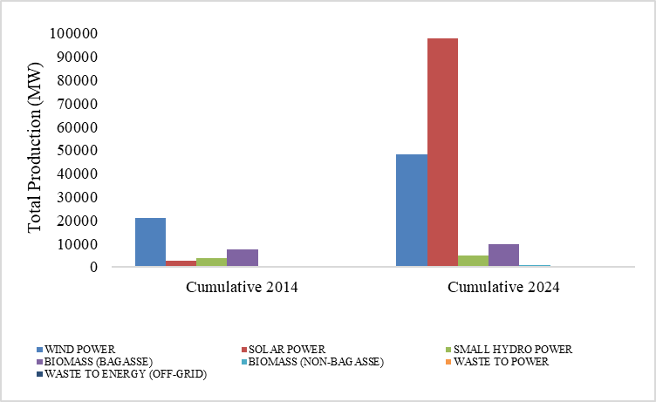

Figure 4 - Variation in Cumulative RE Growth (IND)

India has undergone a significant transformation in its renewable energy landscape since 2014, wind power was leading the way, but by 2024, solar power had taken the spotlight growing massively to nearly 100 GW and becoming the country’s top renewable energy source. This surge reflects strong government support, falling solar costs, and a focus on clean, scalable solutions. While wind energy also grew, it couldn't match the pace of solar. Other sources like biomass (from both bagasse and non-bagasse), small hydro, and waste-to-energy saw slight increases, rest showing they remain, the real momentum is behind solar. This decade-long trend clearly shows that India is betting big on solar as the future of its green energy journey.

Figure 5 - RE Contribution States-wise (India - 2024)

India’s renewable energy capacity in figure 5, with ***Gujarat*** leading the charge at ***15.68%****,* thanks to its strong infrastructure and commitment to clean energy. ***Maharashtra*** follows with ***10.74%****,* while ***Tamil Nadu***, a pioneer in wind energy, contributes ***9.88%****.* ***Karnataka*** adds a solid ***7.91%****,* with ***Andhra Pradesh*** *and* ***Rajasthan*** both contributing ***6.60%****,* establishing themselves as major players in the country’s renewable landscape. States like ***Madhya Pradesh (5.60%)****,* ***Telangana (5.27%)****,* and***Uttar Pradesh (4.95%)*** fall into the moderate range, along with ***Kerala****,* ***West Bengal (3.30% each)****,* ***Odisha (2.63%)****,* ***Punjab (2.97%)****, and* ***Haryana (2.11%)****,* indicating steady but not leading contributions. On the lower end, many Northeastern and smaller states such as ***Bihar (1.98%)****,* ***Jharkhand (1.32%)****,* ***Himachal Pradesh (1.00%)****,* and***Assam (1.00%)*** contribute modestly, while others like ***Manipur, Meghalaya, Mizoram, Nagaland****,* and***Sikkim*** register below ***1%****.* Union territories like ***Dadra and Nagar Haveli****,* ***Daman and Diu****,* and***Goa*** contribute minimally less than **0.05%** reflecting either geographic limitation, it can be representing in under developed infrastructure.

Figure 6 - RE Contribution Districts-wise (BREDA - 2024)

**Patna** emerges as the leading contributor with a production rate exceeding **13%**, making it the most dominant district in the state. ***Gaya*** *and* ***Bhagalpur*** follow closely, each contributing around **9% and 8%**, respectively, placing them well above the average, districts like ***Muzaffarpur*** *and* ***West Champaran*** also show approximately **6.5%**. ***Purnia, Darbhanga and East Champaran, Nalanda, Saran led the approximate to 4%.***

Large number of districts, including ***Arwal, Jamui, Munger, Sheohar****, and* ***Supaul***, minimal contribution, each with production rates well below **2%**. These figures suggest a marked disparity in agricultural output across the states. Districts like ***Arwal, Banka, Buxar, Bhojpur, Gopalganj, Jamui, Jehanabad, Kaimur, Katihar, Khagaria, Kishanganj, Lakhisarai, Madhepura, Munger, Nawada, Rohtas, Saharsa, Samastipur, Sheikhpura, Sheohar, Supaul, Vaishali*** are very low containing below 1% productivity and having least scope but the geographical as well demographical are well.

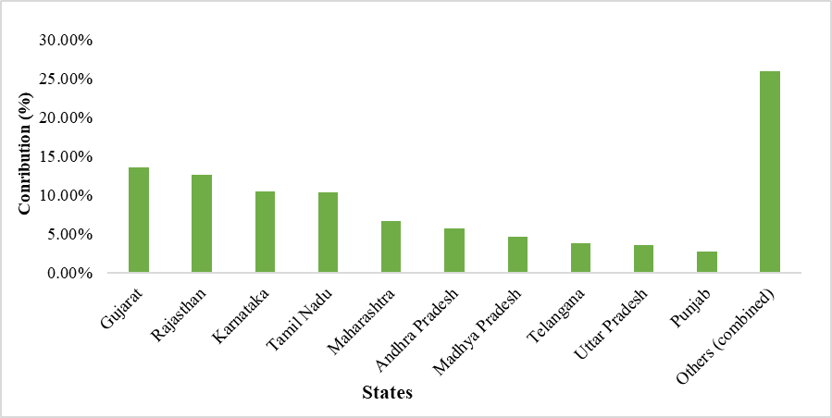 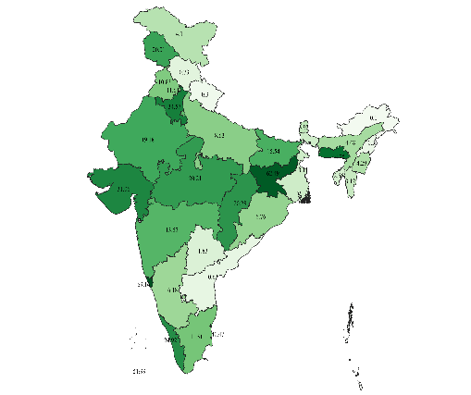

Figure 7 - Major states were contributions in RE Potential & growth of RE in India (APR-2025)

India’s renewable energy (RE) installed capacity reached approximately 203.18 GW, accounting for over 46.3% of the country's total installed electricity generation capacity of 452.69 GW target of achieving 500 GW till the mission of SDGs by 2030. The leading contributors to this growth are Rajasthan, Gujarat, Karnataka, Himachal Pradesh, and Tamil Nadu, which together account for around 56% of the national RE output. In solar energy, Rajasthan, Karnataka, Gujarat, Tamil Nadu, and Andhra Pradesh dominate, contributing over 75% of the country’s solar generation, while Gujarat, Tamil Nadu, Karnataka, Andhra Pradesh, Rajasthan, and Maharashtra jointly produce about 93% of India's wind energy. For large hydropower, Himachal Pradesh, Jammu and Kashmir, Uttarakhand, Karnataka, and Sikkim together generate 62.47% of the national output. Gujarat leads the nation in total renewable energy capacity at 27.46 GW, which is 14.41% of India's total RE capacity, and has notably increased its RE share in total state capacity from 28.45% in 2017–18 to 51.87% by 2023–24, underscore the prominent role of specific states in advancing India’s renewable energy sector, each leveraging their regional strengths in solar, wind, or hydro power.

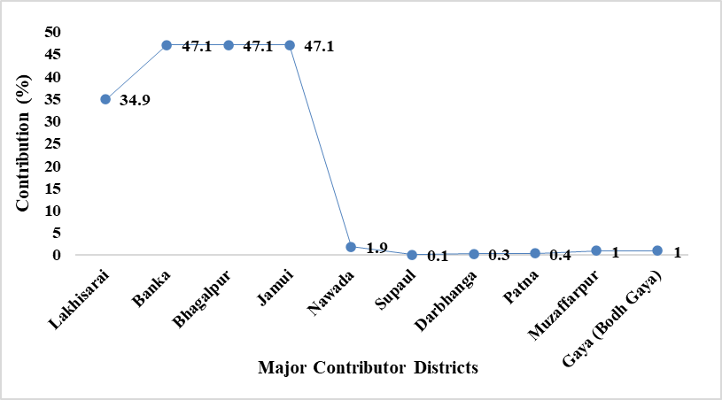 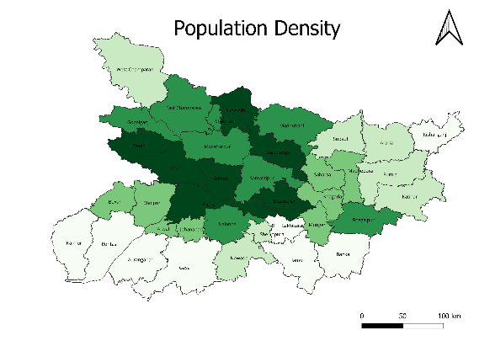

Figure 8 - Major RE Productive Districts (Bihar) with demographical indeed with Population

Population and its density very high comparable with all other states and much need of development in in energy sector for utilities and Northern-West region of Bihar (*Sitamarhi, Darbhanga, Begusarai, Patna, Siwan, Saran, Vaishali, East Champaran, Muzaffarpur, Gopalganj, Samastipur, Nalanda and Begusarai).* Demographical issues significances led development for energy utilities and need for sustainable free energy for all.

*Banka, Bhagalpur, and Jamui* are leading Bihar's renewable energy charge, contributing a 47.1% each from the solar plant as well biomass, while *Lakhisarai* also contribute solar follows with 34.9%. Other districts like *Nawada, Supaul, Darbhanga, Patna, Muzaffarpur, and Gaya Ji (Bodh Gaya)* are making smaller contributions, ranging from 0.1% to 1.9%.

Bihar's total renewable energy contribution to India stands at 6.7%, and with strong initiatives from BREDA, the state is pushing to become one of the top 10 green energy producers by 2030. *Nawada*, solar energy and biomass power role, while *Supaul* benefits from hydropower and emerging solar projects. Darbhanga utilizes biomass energy alongside growing solar infrastructure, and Patna focuses on solar energy and innovative waste-to-energy. *Muzaffarpur* harnesses biomass power and expanding solar farms, *Bodh Gaya* explores solar power with early-stage wind energy considerations (BREDA, 2024).

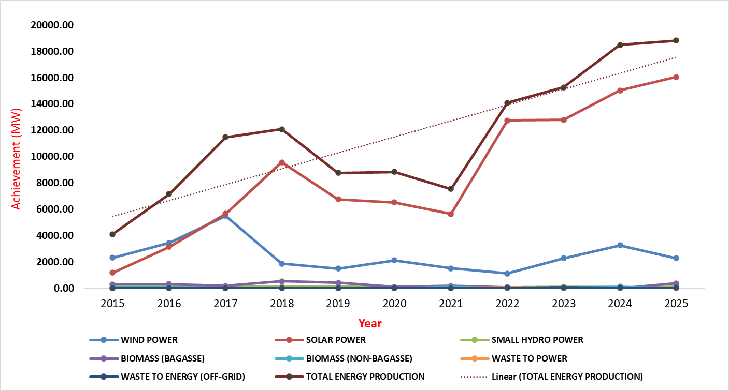

Figure 9 - Trends of total RE (INDIA)

From 2015 to 2025, India's renewable energy generation shows significant variation across sources, with solar power exhibiting the highest variance (24.3 million), reflecting rapid growth and fluctuations, while wind power shows moderate variance (1.5 million). A t-test comparing wind and solar energy reveals a statistically significant difference (t = -4.03, p = 0.00065), confirming that solar generation levels are consistently higher.

An ANOVA test across all energy types yields an F-value of 30.72 and a p-value is very less, indicating strong statistical evidence of differences in mean generation among the various renewable sources. The year challenging in the tenure 2016-2019 and 2023-2025 in India, the production of the energy through the renewable is the higher efficiency and growth tend to get increasing and significance with trend as well as further move to decade after forecasting of the generation or production rate.

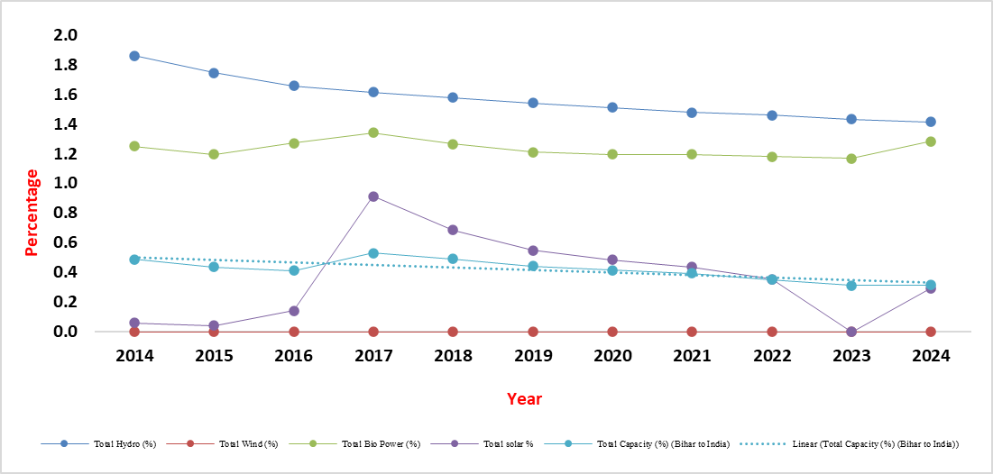

Figure 10 - Composition of RE to Nation from Bihar (8%)

Bihar’s contribution to India’s renewable energy capacity has changed from 2014 to 2024. Throughout these years, Bihar had no role in wind energy, and its share in hydro power slowly declined from around 1.86% in 2014 to about 1.41% in 2024. The bio power contribution stayed mostly steady with small ups and downs, while solar power initially grew, reaching a high in 2017, but then sharply dropped to zero in 2023 before slightly rising again in 2024.

After we should be discussing the impacts of climatic factors and renewable potential across the nation level and state or regional level. The first table discussing about the Renewable Energy Possibilities and utilisation in national level with different climatic and weather pattern were suitable in the areas. The rows were highlighted with **navy-*blue background*** in table its denoting with ***8 UT (Union Territories)*** which came under the supervision under and progress report by the central government and expect all are ***28 states***.

In second table the discussion about the selected regional of Bihar and showing Renewable Energy Possibilities and climatic factor influencing. It indicating that the major factors regarding climatic like high temperate, urban heat, flood prone zone where, the biogas and biomass energy generation in the region. It also showing the perspective regarding how developing nation and what is the role of regional and contribution toward the nation, it gives their best 7-8% of renewable energy production and massive achievement in rural and urban development, the progress also led into the awareness, education, employment to rebuild the energy in the villages.

The latest sources of data availability about *Ministry of Statistics* regarding the renewable potential from renewable energy collected by *NGO & IREDA*. RE capture about 21% power generation while, India uses 47.46% of RE Productions of 441.97 GW. Bihar 0.45 GW for Electrification and (15.54%) growth rate in annual as compare to previous annual capture of energy. RE contribute 7% total RE out of total power generation in the Bihar region.

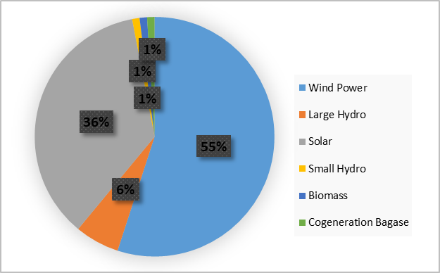In India, renewable energy is primarily driven by wind and solar power, which constitute 55% and 36% of the total renewable energy mix, respectively. Large hydro contributes 6%, while small hydro, biomass, and cogeneration from bagasse each account for 1%.

Figure 11 - RE (%) in Bihar

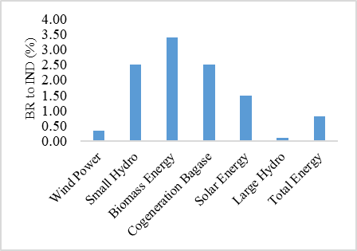Bihar contributes 0.81% to India’s renewables, with 3.39% biomass, 2.51% bagasse, 2.49% small hydro, 1.5% solar, 0.35% wind, and 0.10% large hydro. This indicates that Bihar’s renewable energy profile leans more on biomass and small hydro, while it lags significantly in wind and solar contributions.

Figure 12 - RE Bihar to India shares

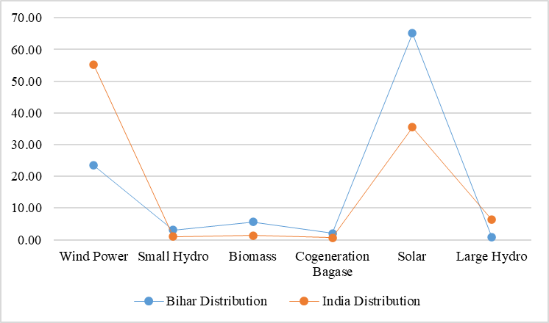Bihar’s RE dominated by solar power at 65.15%, significantly higher than India’s 36%. Wind contributes only 23.4% in Bihar versus 55% nationally. Biomass (5.61%) and small hydro (3.07%) also exceed national averages, while cogeneration (2.02%) and large hydro (0.76%).

Figure 13 - Composition of RE (Bihar & India)

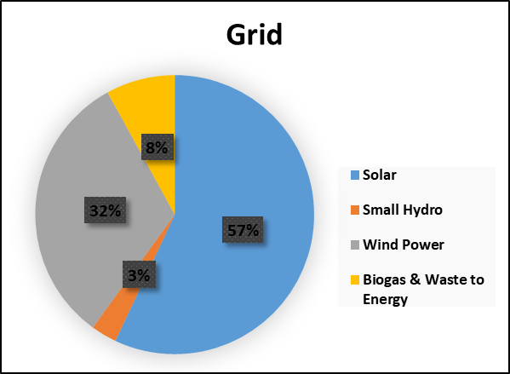 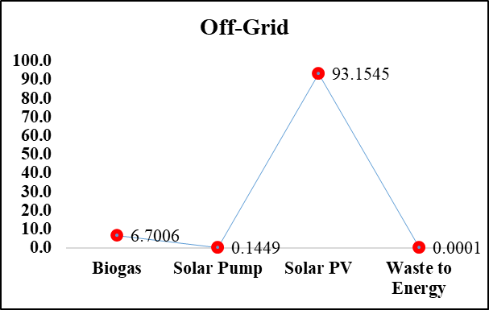

Figure 14 - Grid and off-Grid Electrification in Bihar with the Renewable technologies

Grid and off-grid potential productivities representation in Bihar, it gives 7-8% to the nation and aiming to be in top 10 announcing by CEA-NEP at upcoming end of the tenure SDGs goal 2030. In table 1, green highlight to Bihar and mention their potential in table 2.

Table 1 - Renewable Energy Possibilities and climatic factor influencing (INDIA)

|  |  |
| --- | --- |
| **States and UTs** | **Renewable Energy Possibilities** |
| Andaman and Nicobar Islands | Rooftop Solar, Ocean Energy |
| Andhra Pradesh | Wind, Solar Parks, Rooftop Solar, Biomass, Small Hydro |
| Arunachal Pradesh | Small Hydro, Solar, Biomass |
| Assam | Solar, Biomass, Small Hydro |
| Bihar | Rooftop Solar, Biomass, Solar Parks, Small Hydro |
| Chandigarh | Rooftop Solar |
| Chhattisgarh | Biomass, Solar, Small Hydro |
| Dadra & Nagar Haveli and Daman & Diu | Rooftop Solar, Urban Solar Lighting, Solar Mini-Grids |
| Delhi | Rooftop Solar, Waste-to-Energy |
| Goa | Solar, Rooftop Solar, Biomass |
| Gujarat | Wind, Solar Parks, Rooftop Solar, Biomass |
| Haryana | Rooftop Solar, Biomass, Solar Pumps |
| Himachal Pradesh | Small Hydro, Solar |
| Jammu and Kashmir | Small Hydro, Solar |
| Jharkhand | Biomass, Rooftop Solar, Small Hydro |
| Karnataka | Wind, Solar Parks, Rooftop Solar, Biomass |
| Kerala | Small Hydro, Rooftop Solar, Wind |
| Ladakh | High-Efficiency Solar, Wind, Geothermal |
| Lakshadweep | Rooftop Solar, Ocean Energy |
| Madhya Pradesh | Solar Parks, Wind, Rooftop Solar, Biomass |
| Maharashtra | Wind, Solar, Rooftop Solar, Biomass, Bagasse Cogeneration |
| Manipur | Small Hydro, Rooftop Solar |
| Meghalaya | Small Hydro, Solar |
| Mizoram | Small Hydro, Solar |
| Nagaland | Small Hydro, Solar |
| Odisha | Solar Parks, Rooftop Solar, Biomass, Wind |
| Puducherry | Rooftop Solar |
| Punjab | Rooftop Solar, Biomass, Solar Pumps |
| Rajasthan | Solar Parks, Wind, Rooftop Solar, Biomass |
| Sikkim | Small Hydro, Solar |
| Tamil Nadu | Wind, Solar Parks, Rooftop Solar, Biomass |
| Telangana | Solar Parks, Rooftop Solar, Biomass |
| Tripura | Biomass, Rooftop Solar |
| Uttar Pradesh | Rooftop Solar, Biomass, Solar Parks, Small Hydro |
| Uttarakhand | Small Hydro, Solar |
| West Bengal | Rooftop Solar, Biomass, Solar Parks |

Table 2 - Renewable Energy Possibilities and climatic factor influencing (BIHAR)

|  |  |  |
| --- | --- | --- |
| **District** | **Renewable Energy Possibilities** | **Climatic Factors** |
| **Araria** | Biogas from (Agri.) residues | Wettest district, prone to floods |
| **Arwal** | Solar rooftop systems | Dry conditions, semi-arid tendencies |
| **Aurangabad** | Solar thermal systems | Moderate rainfall, drought-prone |
| **Banka** | Small hydro projects | Hilly terrain, moderate rainfall |
| **Begusarai** | Solar irrigation systems | Fertile plains, moderate rainfall |
| **Bhagalpur** | Solar street lighting | Fertile floodplains, moderate winters |
| **Bhojpur** | Biogas production | Fertile lands, moderate temperature |
| **Buxar** | Solar drying systems | Semi-arid tendencies, moderate rainfall |
| **Darbhanga** | Solar water pumps | Flood-prone, fertile lands |
| **E. Champaran** | Solar village electrification | High rainfall, prone to waterlogging |
| **Gaya Ji** | Solar thermal water heaters | Semi-arid, drought-prone |
| **Gopalganj** | Biogas from sugarcane residues | Flood-prone, fertile lands |
| **Jamui** | Mini hydro projects | Hilly terrain, moderate rainfall |
| **Jehanabad** | Solar rooftop systems | Moderate rainfall, fertile plains |
| **Kaimur** | Solar-powered cold storage | Plateau region, cooler winters |
| **Katihar** | Solar water pumps | High rainfall, fertile plains |
| **Khagaria** | Biogas production | Flood-prone, fertile lands |
| **Kishanganj** | Small hydro projects | Heavy rainfall, high humidity |
| **Lakhisarai** | Solar water heating systems | Moderate rainfall, fertile plains |
| **Madhepura** | Solar-powered microgrids | Flood-affected, fertile lands |
| **Madhubani** | Solar irrigation systems | High rainfall, frequent floods |
| **Munger** | Biogas from livestock waste | Fertile floodplains, moderate rainfall |
| **Muzaffarpur** | Solar dryers (Agri.), Biogas | Flood-prone, high humidity (monsoon) |
| **Nalanda** | Solar rooftop systems | Semi-arid tendencies, moderate rainfall |
| **Nawada** | Solar street lighting | Semi-arid, moderate rainfall |
| **Patna** | Solar smart grids | Hot summers, moderate winters, urban heat effect |
| **Purnia** | Solar water pumps | High humidity, heavy monsoon rains |
| **Rohtas** | Biogas from crop residues | Hilly terrain, moderate rainfall |
| **Saharsa** | Solar dryers | Flood-prone, heavy monsoon rainfall |
| **Samastipur** | Solar irrigation systems | Fertile plains, moderate rainfall |
| **Saran** | Solar rooftop systems | Fertile lands, moderate rainfall |
| **Sheikhpura** | Solar water heating systems | Moderate rainfall, fertile lands |
| **Sheohar** | Biogas from (Agri.) residues | Flood-prone, high monsoon intensity |
| **Sitamarhi** | Solar water pumps | Heavy rainfall, frequent flooding |
| **Siwan** | Solar-powered microgrids | Fertile plains, moderate rainfall |
| **Supaul** | Small hydro projects | High rainfall, prone to flooding |
| **Vaishali** | Solar rooftop systems | Moderate rainfall, fertile plains |
| **W. Champaran** | Solar village electrification | Heavy rainfall, forested areas |

## Potential of demanded renewable sources in significant districts

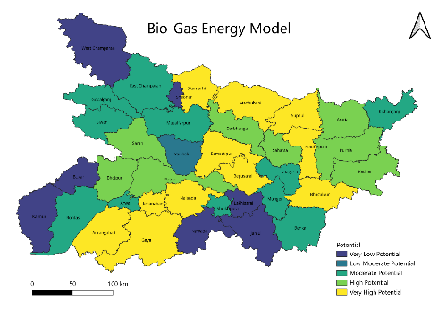 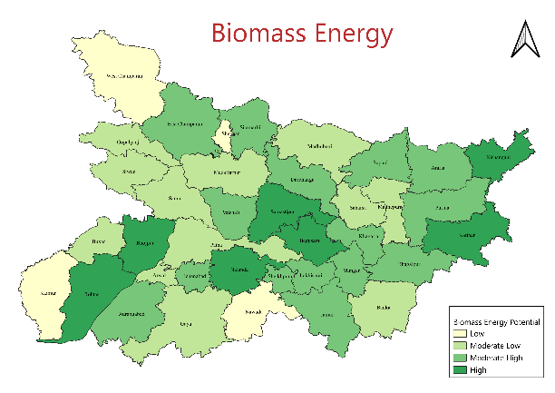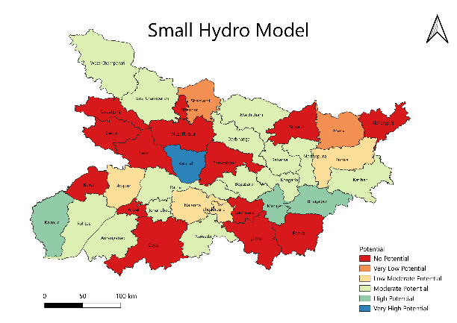 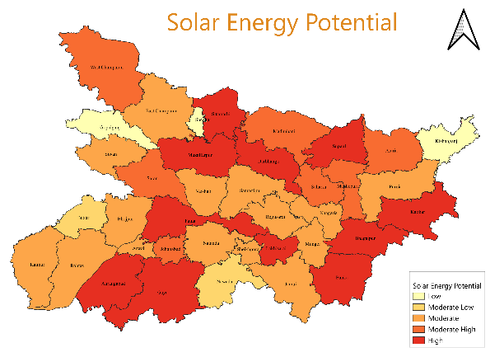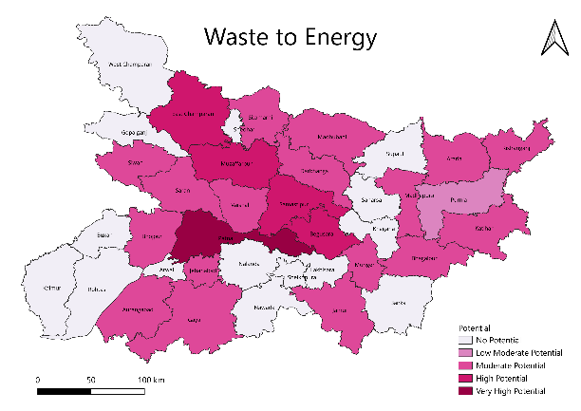 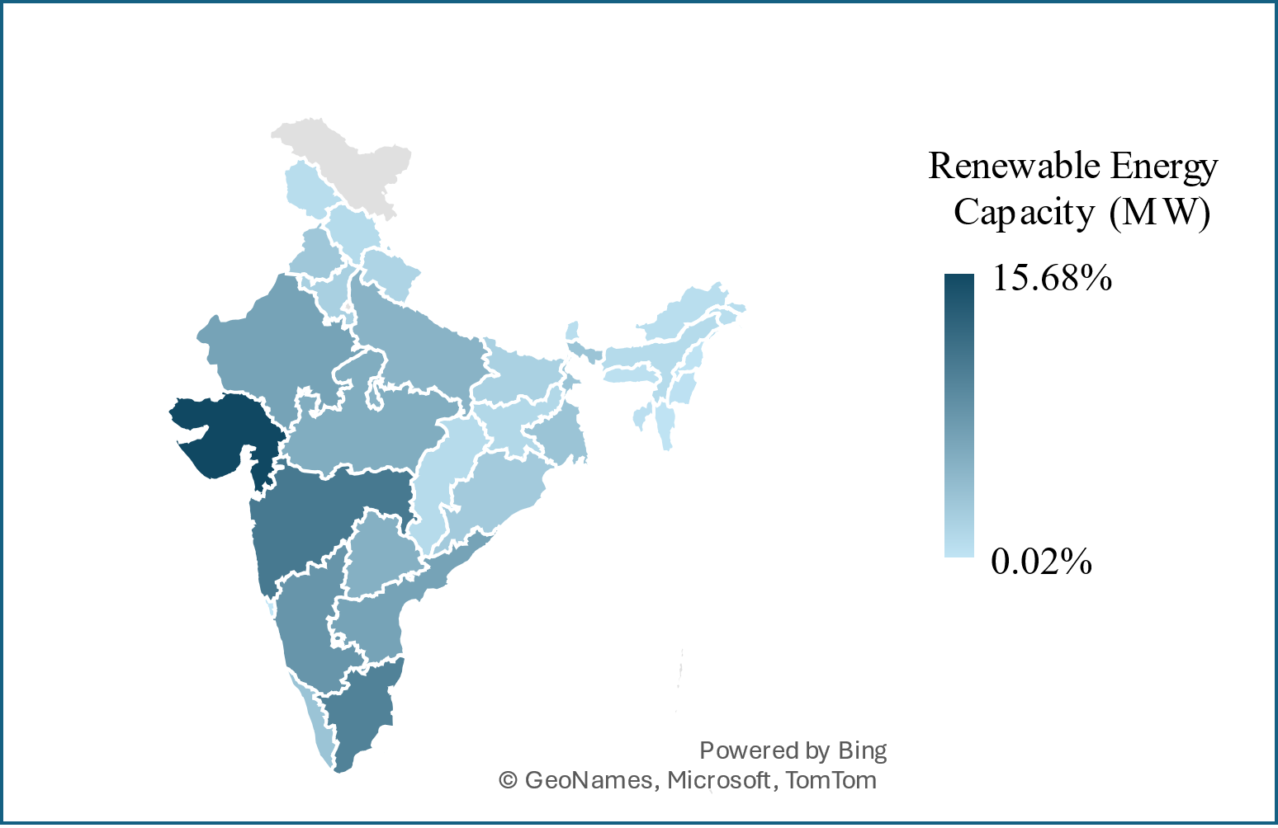

Figure 15 - RE scope potential districts in Bihar and India (2024)

In figure 15, representing the possible productivity of renewable energy source like Biogas, Biomass, Small Hydro, Solar Model and waste to energy are potential as well focus to target to reach the mission. In figure 16 represent the mission to achieve the goal contribute wind, hydro, solar and other in percentage to escape the achievement cumulative till 43.33% to enrich the target and developing the progressive of RE with ET utilities for communities.

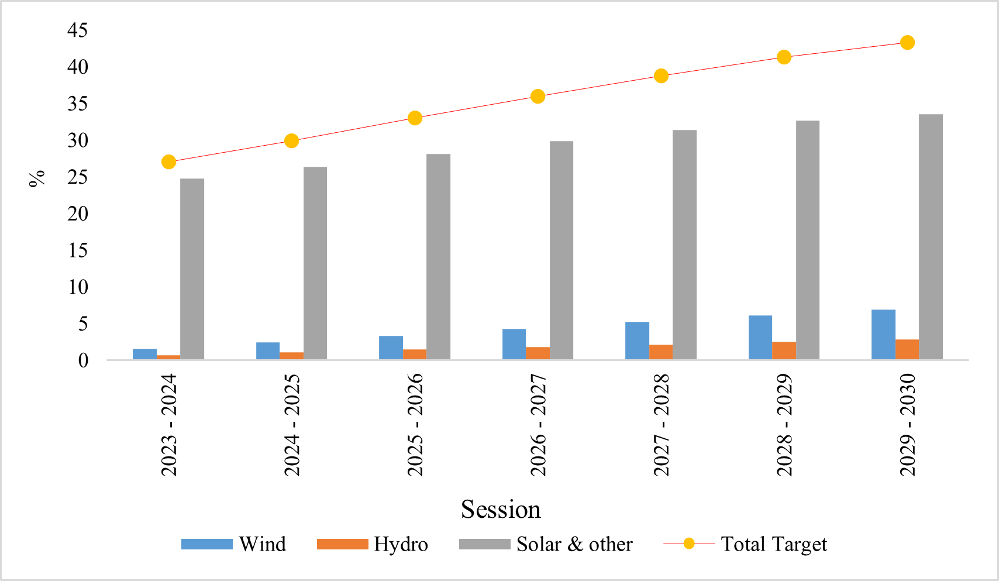

Figure 16 - Target green energy till SDGs mission of Bihar

## Responder’s interaction toward to the assessment of Emerging technologies

### Renewable Model development in the Rural Areas

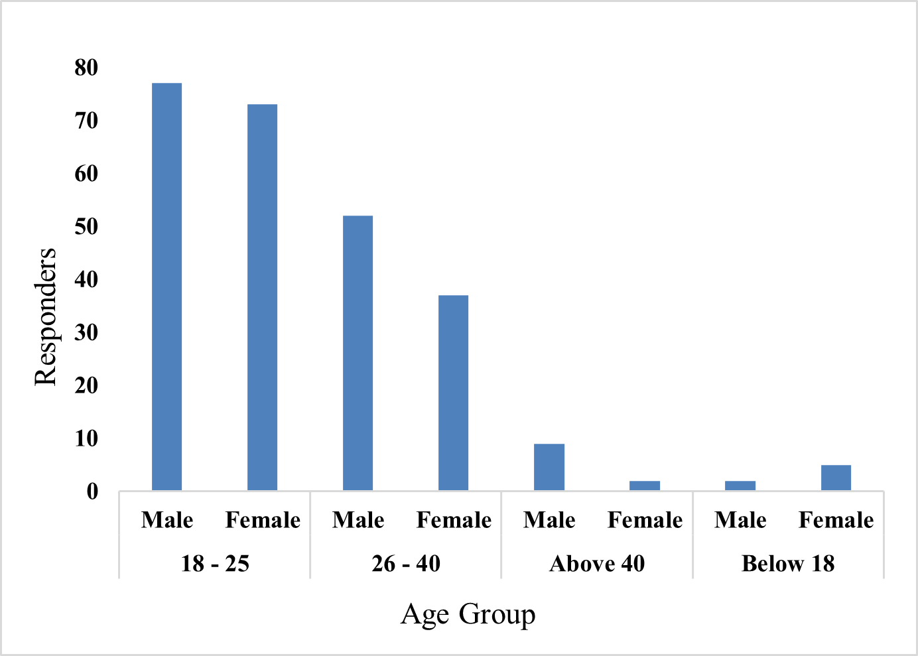The data shows that the highest participation is from the 18–25 and 26-40 age group with nearly equal gender representation, while overall male responders outnumber females in all age groups except the below-18 category.

Figure 17 - Age-Gender Participants

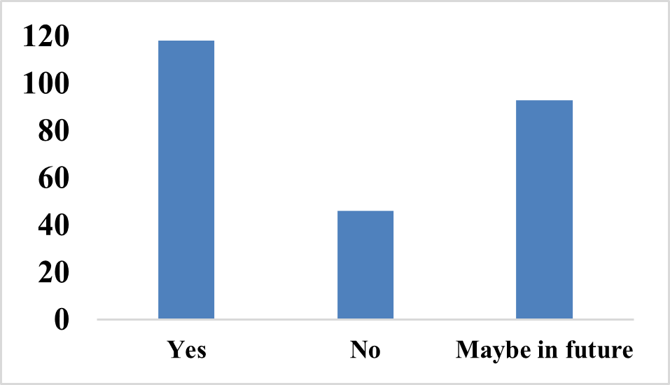The data indicates that over 80 percent of respondents are either currently using or considering the use of renewable energy sources, reflecting a positive trend toward sustainable energy adoption.

Figure 18 - Utilizing RE Model in their home

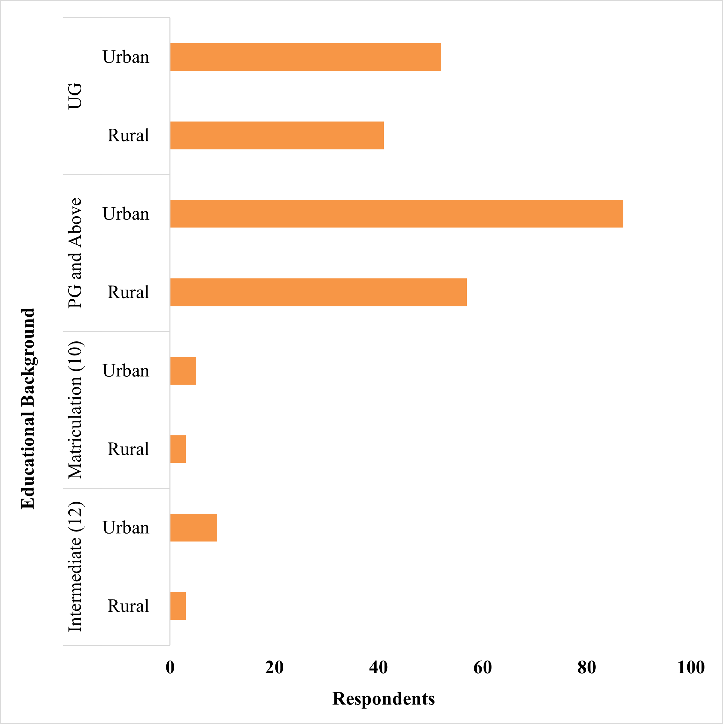The graph reveals that most respondents, especially from urban areas, hold postgraduate or undergraduate degrees, while few possess only Intermediate or Matriculation qualifications, urban participants more likely to have higher academic qualifications than rural ones.

Figure 19 - Educational Background Categorization

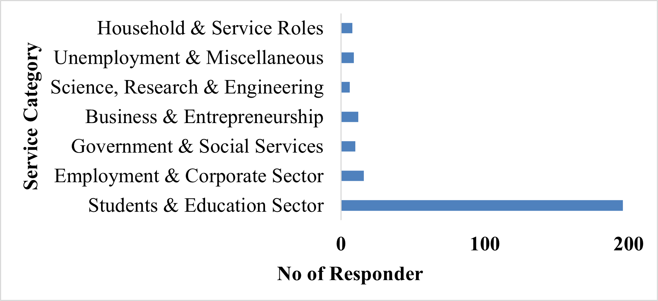Students and Education Sector, with nearly 200 respondents, while all other occupational categories have minimal presence. This imbalance indicates a demographic skew toward academically engaged individuals, suggesting potential sampling bias of employment or sector-related insights.

Figure 20 - Responders Occupational scene

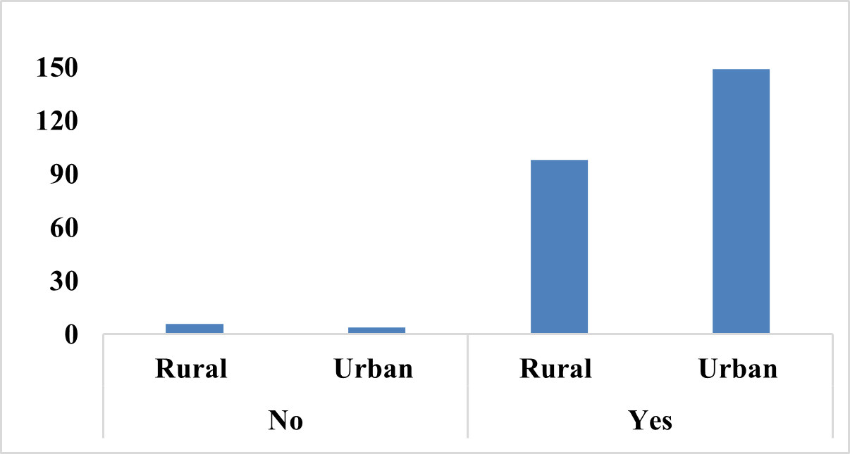The graph shows high awareness and involvement in environmental modelling and renewable energy, with strong participation from both urban and rural respondents, particularly urban. Minimal “No” responses, supporting the view that urban areas lead due to greater access to resources and institutional.

Figure 21 - Environmental modelling and Renewable energy

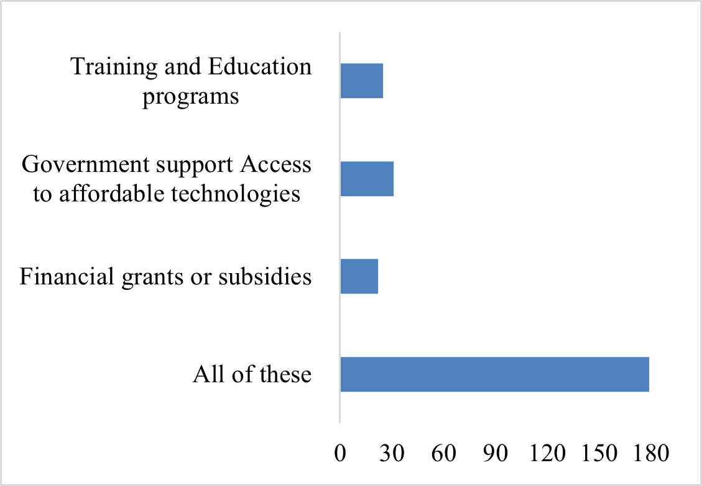Community support is most favoured when utilizing a holistic approach, combining training and education programs, government support, and financial grants. This preference for comprehensive support indicates that integrated strategies may be more effective for community development than focusing on individual aspects.

Figure 22 - Support aspects need into community

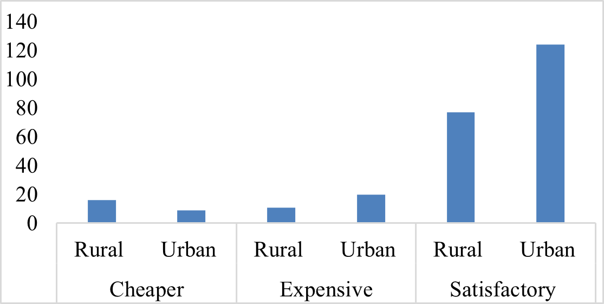Higher energy utility engagement and satisfaction in urban areas, especially with costlier options, while rural areas show lower usage and satisfaction with cheaper services. This disparity underscores unequal access and satisfaction levels, indicating a need for targeted improvements in rural energy infrastructure and service quality.

Figure 23 - Cost estimation or power utilities in household

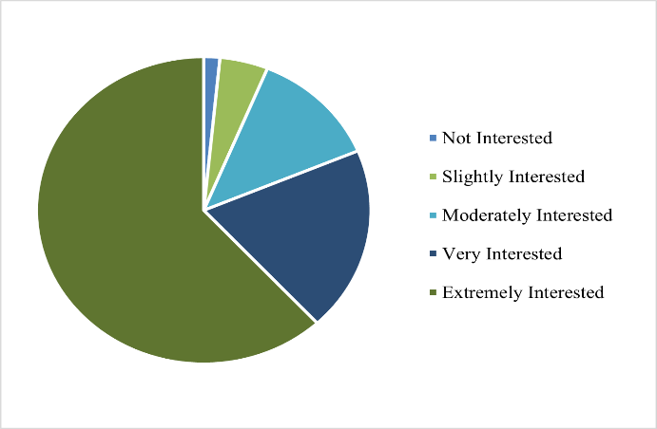RE model integration, with a notable trend toward "Very Interested" and "Extremely Interested" categories, indicating strong enthusiasm. Lower interest levels suggest potential engagement barriers. Overall, the data highlight opportunities for targeted strategies to foster greater involvement in renewable energy research.

Figure 24 - Seeking interest in Extreme Research

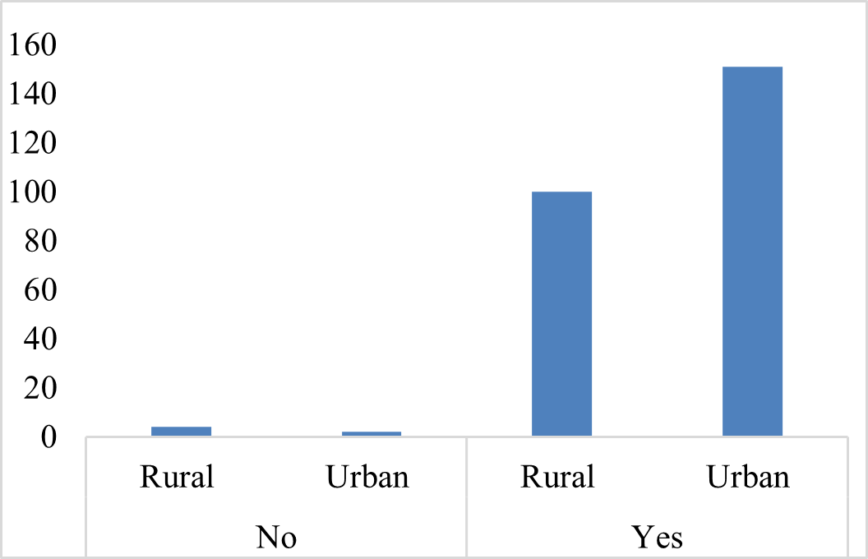The graph reveals a significant gap in SDG awareness between urban and rural populations, with urban respondents showing high familiarity and rural respondents largely unaware. This disparity underscores the need for focused educational efforts in rural areas to enhance understanding and engagement with Sustainable Development Goals.

Figure 25 - Awareness to SDGs Goals

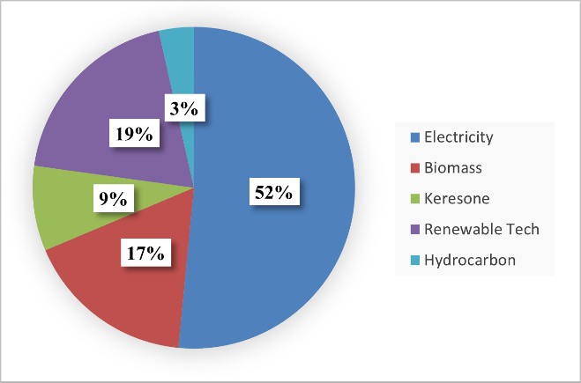Electricity is the dominant energy source at 52%, followed by renewable technologies at 19%, biomass at 17%, kerosene at 9%, and hydrocarbons at 3%. This distribution highlights electricity’s central role while also reflecting the use of renewable and traditional energy sources in the mix.

Figure 26 - Main sources of Energy Utilities in household

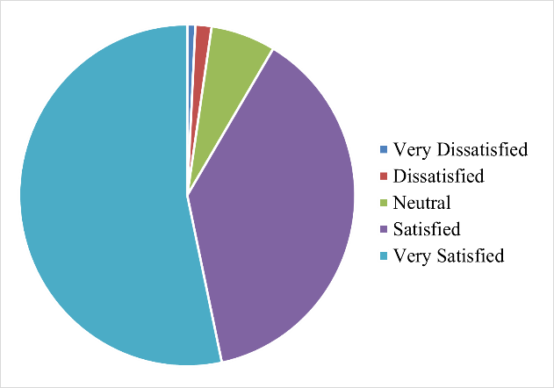Results access in positive perception of renewable energy’s impact on sustainability among rural respondents, with most expressing satisfaction. This reflects growing awareness and acceptance of renewable technologies, increasing role in energy needs and sustainability goals for importance of expanding renewable energy initiatives in rural areas.

Figure 27 - RE trends with sustainability

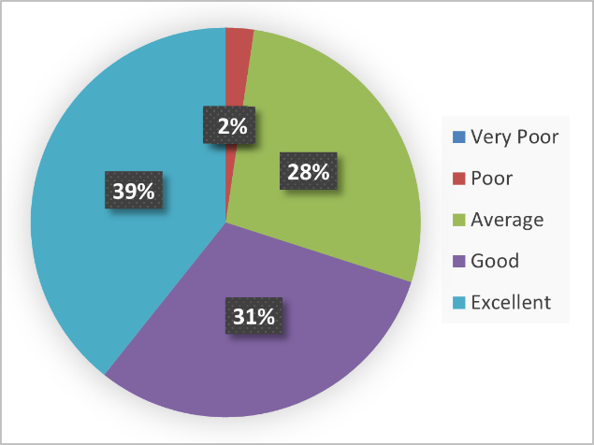It reveals that 2% of rural respondents perceive the nation's progress toward SDGs as "Poor," with 28% rating it as "Average" and 31% as "Good." Majority (39%) view it as "Excellent," highlighting satisfaction and the need for improved strategies to align national efforts with sustainable development goals.

Figure 28 - Achievement tends with SDGs goal

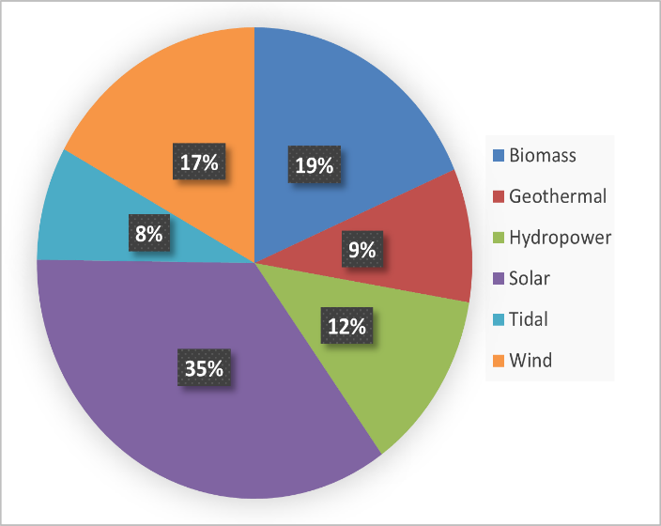Emerging Technologies like Solar energy dominates with 35%, indicating its strong reliance and effectiveness in minimizing environmental impact. Biomass follows at 19%, highlighting its potential contempt environmental concerns. Wind energy accounts for 17%, clean energy source, while hydropower represents 12%, Geothermal energy, at 9%, and tidal energy, the smallest segment at 8%.

Figure 29 - ET depends on RE positive impacts to Environmental Factors

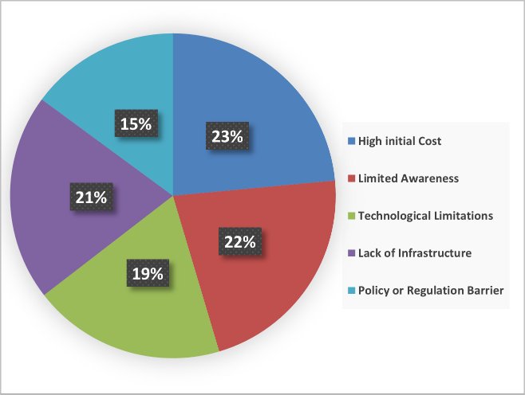

RE installation are High Initial Cost (23%), Limited Awareness (22%), Technological Limitations (21%), Lack of Infrastructure (19%), and Policy or Regulation Barriers (15%). These findings highlight the need for targeted solutions to address financial, knowledge, technological, infrastructure, and regulatory obstacles.

Figure 30 - Challenges led in ET installation

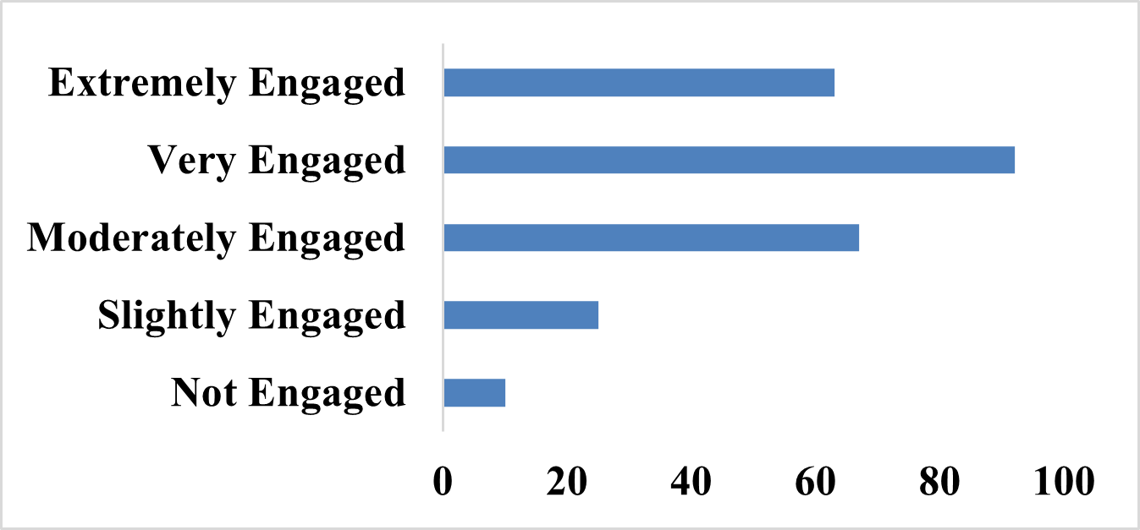Emerging technologies, with 35.79% of respondents being "Very Engaged" and 24.51% "Extremely Engaged." Another 26.07% are "Moderately Engaged," while 9.72% are "Slightly Engaged" and 3.89% are "Not Engaged." This indicates a predominantly positive attitude towards renewable energy solutions.

Figure 31 - Currently Emerging technologies working accuracy in locals

Demand in electricity demand, India has set ambitious goals to meet future needs through renewable sources to improvement of peak met and peak demand of an energy. Renewable energy initiatives with Sustainable Development Goals (SDGs) with a primary focus on SDG 7: Affordable and Clean Energy and SDG 13: Climate Action. It also cleans energy reduces pollution and health risks (SDG 3), creates green jobs and supports economic growth (SDG 8), and promotes sustainable infrastructure through innovation (SDG 9).

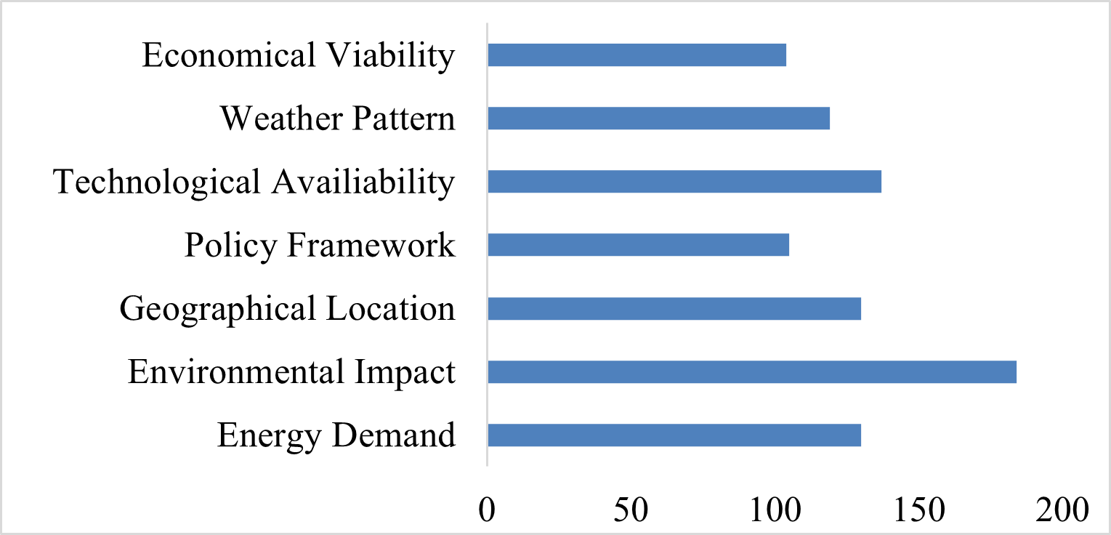Environmental Impact stands out with the highest percentage at 71.6%, indicating significant relevance. Technological Availability at 53.3%, and Geographical Location and Energy Demand, both at 50.6%. Weather Pattern accounts for 46.3%, Policy and Economic Viability are at 40.9% and 40.5%.

Figure 32 - Critical Factors impacts with an Environment

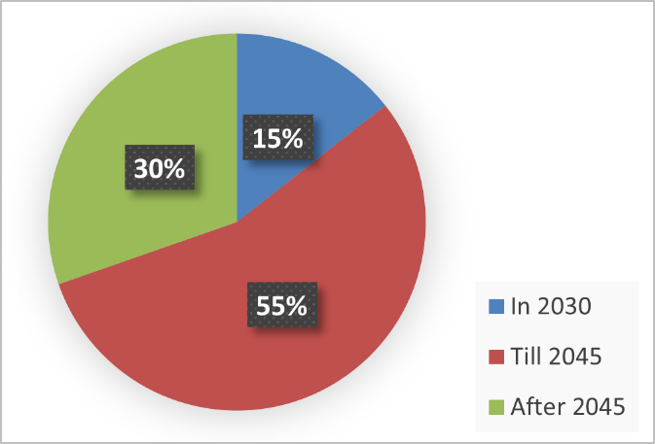The Sustainable Development Goals (SDGs) promote equity and sustainable development by addressing issues like poverty, gender equality, and social inclusion. A pie chart illustrates the distribution of a metric across three timeframes: 2030 (30%), till 2045 (55%), and after 2045 (15%). The benchmark of meeting at least 50% of achievement in equity.

Figure 33 - Equity met half to targeting Achievement

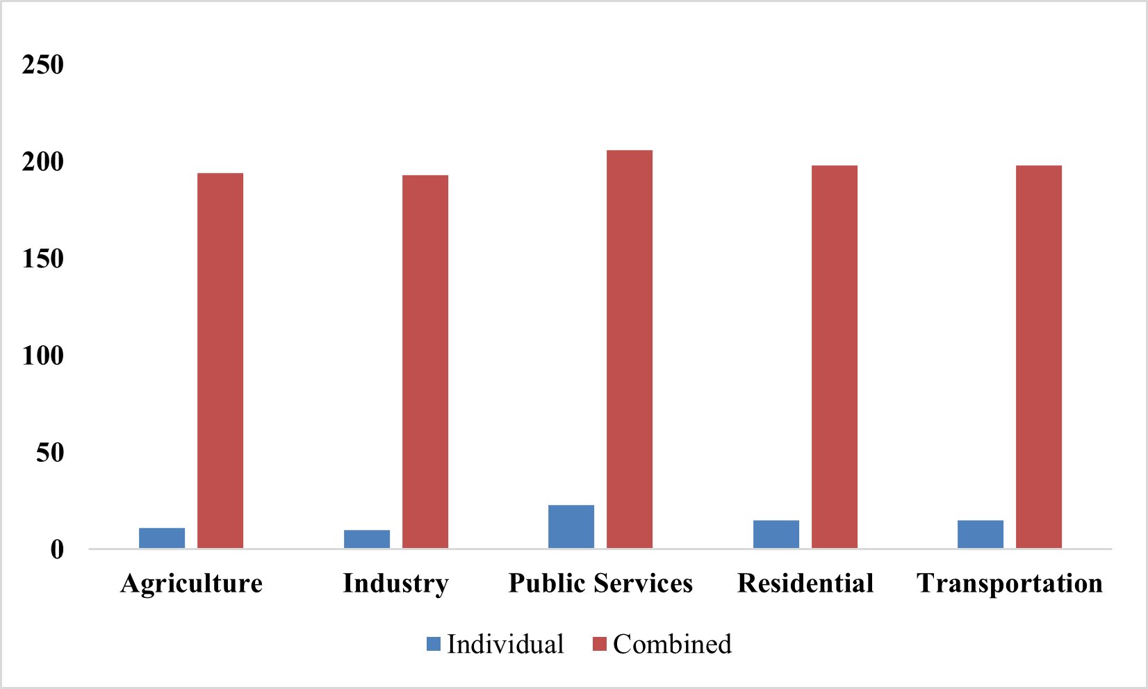

The Sustainable Development Goals (SDGs) promote equity and sustainable development by addressing issues like poverty, gender equality, and social inclusion. A pie chart illustrates the distribution of a metric across three timeframes: 2030 (30%), till 2045 (55%), and after 2045 (15%).

Figure 34 - Equity met half to targeting Achievement

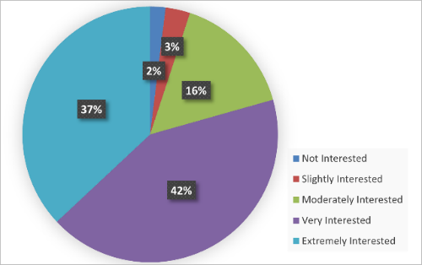Communities interest in renewable energy initiatives, with 42.4% "Very Interested" and 37% "Extremely Interested." A smaller group, 15.6% is "Moderately Interested," while only 3.1% are "Slightly Interested" and 1.9% "Not Interested," indicating positive engagement.

Figure 35 - Moving toward activities in Communities RE

 The benefits received by five sectors from renewable energy (RE), with Public Services showing the highest benefit at approximately 80.2%. Sectors including Agriculture (75.5%), Industry (75.1%), Residential (77%), and Transportation (77%), experience significant. The individual and combine indicate that individual are particular, while the combine were about 183 participants about 71.21%.

Figure 36 - Sector beneficial from the RE (with All of these)

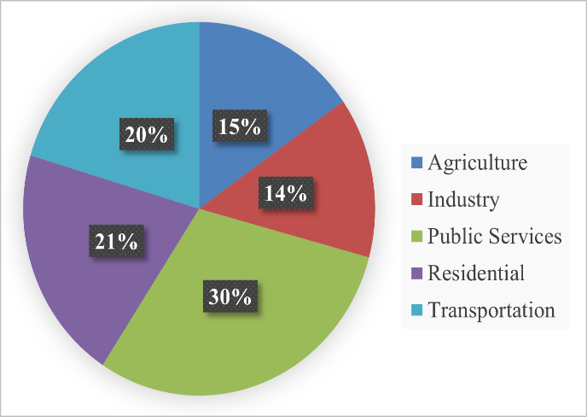Public Services benefiting the most at 30%, followed by Residential (21%), Transportation (20%), Agriculture (15%), and Industry (14%). Renewable energy initiatives positively impact sectors like Public Services, Residential, and Transportation by reducing carbon footprints and promoting climate change mitigation. The negative environmental effects maximize benefits while minimizing harm.

Figure 37 - Beneficial to the sector after initiating with RE

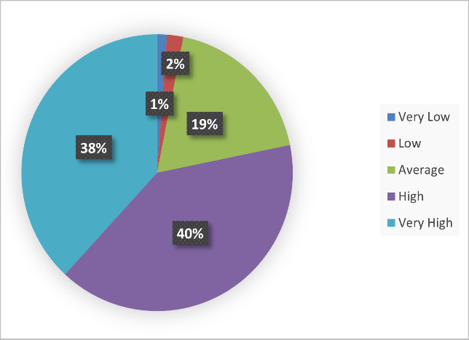The data shows strong support for renewable energy modelling in addressing climate change, with 40.1% (103 respondents) rating its impact as "High" and 38.1% (98 respondents) as "Very High." A smaller portion, 18.7% (48 respondents), rated it "Average," while only 3.1% (8 respondents) expressed scepticism, indicating broad consensus.

Figure 38 - E modelling aspect with addressing to Climate Changes

Bihar aims to be among the top 10 renewable energy producers by focusing on off-grid schemes such as street lighting, home lighting systems, solar lanterns, solar pumps, and standalone power units. The state has significant potential in solar energy, accounting for about 11.2% of the total national potential, followed by biomass, biogas, and small hydro projects.

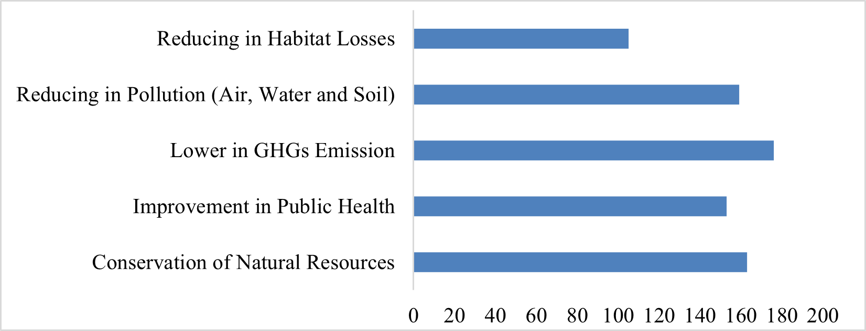Environmental benefits of renewable energy: 68.5% acknowledge reduced GHG emissions, 63.4% recognize resource conservation, and 59.5% see improved public health and benefits include pollution reduction (61.9%) and habitat loss reduction (40.9%), supporting sustainable rural development strategies.

Figure 39 - Environmental consequences benefits from RE

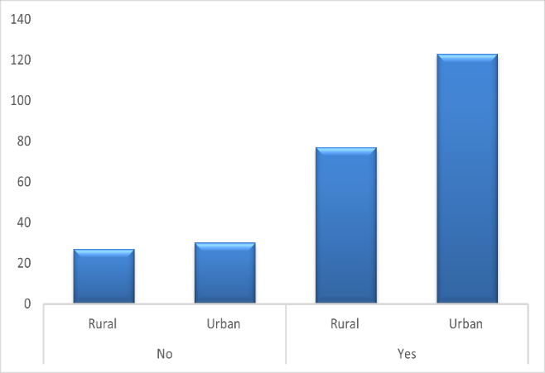Rural and urban respondents regarding renewable energy models consideration of environmental costs. Urban respondents are more likely to believe that the models adequately address these costs, while rural respondents express greater scepticism concerns about the model’s effectiveness.

Figure 40 - Renewable Energy Models Account for Environmental Costs

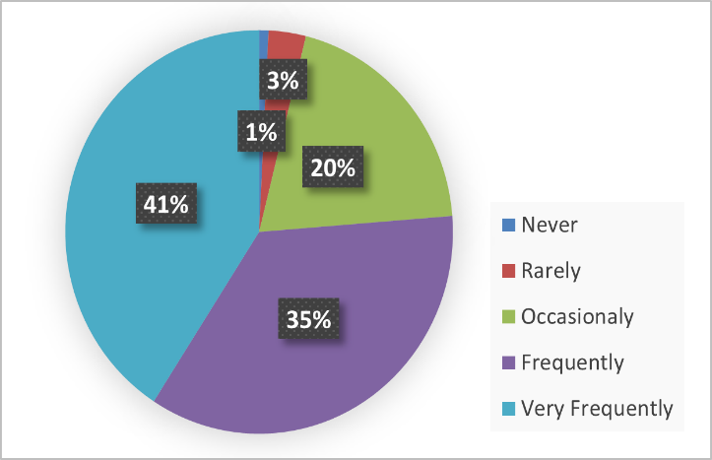Investment in renewable energy modelling and research, with 40.9% of respondents indicating "Very Frequently" and 35.4% "Frequently." A further 19.8% expressed occasional support, while only 3.1% and 0.8% selected "Rarely" and "Never," respectively, reflecting a broad consensus for continued investment.

Figure 41 - Support more investment in renewable energy modelling and research

The potential for emerging sustainable energy technologies across different districts, taking into account geographical and demographic factors, as well as their impacts and strengths. The assessment gives the report of qualitative and quantitative variable from to estimate prediction of assessment to mitigating to Climate changes with emerging technologies in rural Bihar. The need of stakeholder who make funding organising foundation of science congress with their innovative model and how it can implementation in the current scenario impaction with climate changes and solution for alternation of green energy with lower emission modelling scope.

# **Conclusion**

Research acknowledged toward the seeking into the sustainable manner both rural and urban. The statistical test like ***ANOVA, F-Statistics, p-Values*** *or* ***F-crits (significance level of 0.05) and F-distributions (****Values should be greater than 1****)***. The results of the progressive of renewable energy in the leading sector annually increasing and also tends its year wise the change in the variation of giving positive response by the rural as well as semi urban. ANOVA analysis reveals India's renewable energy generation exhibits significant variation, with solar power showing the highest variance, indicating rapid growth and fluctuations, while wind power shows moderate variance. Bihar's contribution to India's renewable energy capacity has fluctuated from 2014 to 2024, with a decline in ***wind energy, hydro power, bio power***, but ***solar power*** it trends to increase with varying levels of growth and decline, but it future showing it give to enhance in increase and growth of RE productivity with multimodal and increase in composition of RE production of Bihar. ***Renewable technologies, land use planning, socio-economic benefits, energy productivity, climate resilience, SDGs.***

The p-values are indicating the less than the 0.05 where we can get the accessible response in growth. Responses from the participants about the questionaries about ***257 responses***, having lower than the p value about ***0.05*** and greater than ***1*** in F-crits, we can reject null hypothesis which conclude that difference in group mean which are stable and highly significance to the research. It gives positive tends regarding the assessment to future trends of renewable energy production should having higher formality into increasing the scope of production and beneficial into the employment, geographical and environmental variability impacts.

***SPSS*** and ***Data analysis*** in ***MS Excel*** helps into the descriptive analysis of the performance of qualitative data, which are significance with pairing or individual functions of the data and suggestion of responder the visualization charts are more attractive toward the result. Pivot functions tools in Excel function which can increase the efficiency of working and selectable data and increase the clarity of the aspects of the results.

Potential of RE in Bihar are ***Waste-to-Energy, Solar Energy, Biomass, Bio-Energy and Small Hydro*** are significant with ***Population Density***. Geographical and Demographic factor were affected to region also enhance the scope according to climatic extreme events factor occurs in the region. Bihar is major sources of RE in phase of solar and biogas are the most viable, scalable renewable energy options due to favourable conditions and government support. While biomass shows potential, other technologies like hydro, wind, and green hydrogen are limited by site constraints and infrastructure needs, making ***solar*** and ***biogas*** the immediate focus. ***Waste to energy*** generation of energy is limited but it works progress is trends in increasing.

# **Future Scope**

***Piezoelectric*** and ***free energy technologies*** contribute to environmental sustainability by enabling clean, decentralized power generation from natural or mechanical sources. Their application in infrastructure, wearables, and off-grid systems reduces fossil fuel dependency, lowers emissions, and supports energy access, aligning with climate goals and promoting long-term ecological and sustainable development.

*Renewable and free energy sources like solar, wind, hydro, biomass, biogas, and waste-to-energy utilize natural or waste resources without fuel costs.* These eco-friendly technologies support clean, decentralized power generation, reduce emissions, and promote sustainability by harnessing sunlight, wind, water flow, organic waste, and heat for long-term energy solutions.

Table 3 - Free generation of energy development in villages with attractive ideas

|  |  |  |  |
| --- | --- | --- | --- |
| **Source (RE)** | **Free Energy Idea** | **Application in Village** | **Benefits** |
| **Biogas** | Household Biogas Plants | Cooking gas from cattle dung and kitchen waste | Waste-to-energy, clean fuel |
| **Biomass** | Biomass Cookstoves | Clean cooking using crop residue or wood | Reduces indoor pollution, saves firewood |
| **Gravity-Based** | Gravity Lights | Lighting without batteries or electricity | Useful in off-grid homes |
| **Hydro Energy** | Micro-hydro Units | Electricity in hilly or river-based villages | Reliable and constant power |
| **Piezoelectric** | Energy Tiles on Village Paths | Power street lights from foot traffic in busy areas | Innovative, low-power lighting |
| **Solar Energy** | Rooftop Solar Panels | Home lighting, water pumps, charging stations | Low-cost power, reduces diesel use |
| **Thermoelectric** | Heat Recovery Units | Generate light from stove heat in rural kitchens | Utilizes waste heat, no extra fuel |
| **Triboelectric** | Cloth or plastic motion generators | Power sensors in weather or irrigation systems | Portable, no fuel, low-cost tech |
| **Waste to Energy** | Organic Waste Digesters | Electricity from village waste (Kitchen or Food) | Manages waste and generates energy |
| **Wind Energy** | Small Wind Turbines | Power for irrigation pumps or schools | Independent energy supply, eco-friendly |

Table 4 - SDGs matrix to enhance the modelling of Emerging RE potential

|  |  |  |
| --- | --- | --- |
| **Goals** | **Missions** | **Scheme Support related to RE Sector** |
| **1** | No Poverty | Creates jobs and improves livelihoods. |
| **2** | Zero Hunger | Supports sustainable farming with solar pumps. |
| **3** | Good Health & Well-being | Enhances healthcare facilities with reliable power. |
| **4** | Quality Education | Powers rural schools for better learning. |
| **5** | Gender Equality | Encourages women’s participation in renewable energy enterprises. |
| **6** | Clean Water & Sanitation | Uses solar water pumps for clean water access. |
| **7** | Affordable & Clean Energy | Promotes solar, wind, and biomass energy projects. |
| **8** | Decent Work & Economic Growth | Creates employment in renewable energy industries. |
| **9** | Industry, Innovation & Infrastructure | Builds renewable energy infrastructure. |
| **10** | Reduced Inequalities | Extends energy access to marginalized and rural communities. |
| **11** | Sustainable Cities & Communities | Improves living standards through electrification. |
| **12** | Responsible Consumption & Production | Promotes biomass and sustainable resource use. |
| **13** | Climate Action | Cuts emissions by increasing renewable energy use. |
| **14** | Life Below Water | Less pollution supports aquatic ecosystems. |
| **15** | Life on Land | Uses biomass sustainably, reducing deforestation. |
| **16** | Peace, Justice & Strong Institutions | Strengthens institutions through good governance of renewable projects. |
| **17** | Partnerships for the Goals | Fosters collaboration between government, industry, and communities. |

With the help of SDGs missions, we can enhance the methodology to **Social, Economical** and **Environmental** are relatable to the factor which are consequence with real development and application in the traditional combine with modern to fix the barrier and benefit for utilities.

# **References**

1. Abdelaziz, M., Ali, M., & Eltamaly, M. (2018). *Modeling and Simulation of Smart Grid Integrated with Hybrid Renewable Energy Systems*.
2. Accone, T., & Lui, R. (2023). *Renewable energy: emerging technologies and innovations*. *November*, 1–5.
3. Adolph, R. (2024). *IREDA - Indian Renewable Energy Development Agency Ltd.* 1–23.
4. Armin Razmjoo, A., Sumper, A., & Davarpanah, A. (2020). *Energy sustainability analysis based on SDGs for developing countries*. *42*(9), 1041–1056.
5. Behera, R. K. (2011). *High Efficient Solar Energy Harvesting System for Bihar Green Energy Initiative*. *2*, 25–28.
6. Bhide. (2011). *Energy poverty: A special focus on energy poverty in India and renewable energy technologies*. *15*(2), 1057–1066. https://doi.org/10.1016/j.rser.2010.11.044
7. BREDA. (2017). *Bihar Policy for promotion of New and Renewable Energy Sources’17*. http://energy.bih.nic.in/docs/renewable-energy-sources-2017.pdf
8. BREDA. (2024). *Bihar Renewable Energy Development Agency ( BREDA ) Department , Government of Bihar invites Request for Proposals ( RFP ) for “ Selection of Agency for Bihar Renewable Energy Development Agency ( BREDA ) RFP FOR Selection of Agency for Communications Man*.
9. CEA. (2011). *CO 2 Baseline Database for the Indian Power Sector User Guide*. *January*, 1–34. http://cea.nic.in/reports/others/thermal/tpece/cdm_co2/user_guide_ver9.pdf
10. Clausen, L. T., & Rudolph, D. (2020). Renewable energy for sustainable rural development: Synergies and mismatches. *Energy Policy*, *138*. https://doi.org/10.1016/j.enpol.2020.111289
11. Dhayal, K. S., Agrawal, S., Agrawal, R., Kumar, A., & Giri, A. K. (2024). Green energy innovation initiatives for environmental sustainability: current state and future research directions. *Environmental Science and Pollution Research*, *31*(22), 31752–31770.
12. Energy. (2024). *India ’ s Renewable Energy Capacity Hits 200 GW Milestone*.
13. Eqra, J. (2018). *The growth of solar off-grid energy technology : a case study of Dharnai solar village in Bihar , India*.
14. Garba Danjumma Sani. (2019). Renewable Energy: Environmental Impacts and Economic Benefits for Sustainable Development. *International Journal of Engineering Research And*, *V8*(08), 547–555.
15. Goel, J., & Rath, S. S. (2022). *Bihar’s Policy and Budgetary Priorities for Transitioning towards Green Economic Recovery*.
16. Government. (2020). *Bihar Renewable Energy Development Agency Expression of Interest (EOI )*.
17. Grimoldi, C. (2018). *Village-scale Multi-Energy system modelling tools : a review and critical analysis*. 2017–2018.
18. Himabindu, M., Revathi, V., Gupta, M., Panicker, M. S., Chandra, P. K., Hamza, L. H. J., & Maan, P. (2024). Employing Piezoelectricity to Generate Sustainable Energy with Green Harmonics. *E3S Web of Conferences*, *529*.
19. Huck, W. (2022). Sustainable Development Goals. *Sustainable Development Goals*.
20. Imai, K., & Palit, D. (2014). Impacts of electrification with renewable energies on local economies: The case of India’s rural areas. *International Journal of Environmental Sustainability*, *9*(2), 1–18.
21. IRENA. (2025). Renewable Energy Statistics. *International Renewable Energy Agency*, 300. http://www.irena.org/publica tions/2017/Jul/Renewable-Energy-Statistics-2017
22. J, C. R. K., & Majid, M. A. (2020). Renewable energy for sustainable development in India: current status, future prospects, challenges, employment, and investment opportunities. Energy, Sustainability and Society, 10(1) | 10.1186/s13705-019-0232-1. *Energy, Sustainability and Society*, *10*(2), 1–36.
23. Jebaraj, S., & Iniyan, S. (2006). A review of energy models. *Renewable and Sustainable Energy Reviews*, *10*(4), 281–311.
24. Kabiraj, M., & Singhal, P. (2023). Renewable Energy Transforming Rural Women. *Kurukshetra*, *February*, 39–44.
25. Karjalainen, J., Käkönen, M., Luukkanen, J., & Vehmas, J. (2014). *Energy Models and Scenarios in the Era of Climate Change*.
26. Kumar, A., Kumar, K., Kaushik, N., Sharma, S., & Mishra, S. (2010). *Renewable energy in India: Current status and future potentials*. *14*(8), 2434–2442.
27. Kumar, A., Prasad, U., & Ohdar, R. K. (2022). Integrated Energy Planning for Energy Management for Sustainable Development in Rural Areas: A Case Study of Jharkhand Village. *International Journal for Research in Applied Science and Engineering Technology*, *10*(8), 1104–1106.
28. Kumar, S. (2021). AN ENHANCED APPROACH TO RENEWABLE ENERGY SYSTEM DESIGN FOR RURAL LOCALITY ELECTRIFICATION IN BIHAR , INDIA. *Neuro Quantology*, *19*(12), 726–735.
29. Kumar, S. (2024). *Economic Transformation in Bihar : Assessing the Impact of Industrial Investment , Skill Development and Employment Generation*. *2*(9), 59–77.
30. Kumari, M. (2023). *Expanding Bihar’s Renewable Energy Market : The Role of Robot-Powered Solutions and Current State of Renewable Energy in Bihar*. *12*, 6458–6471.
31. Maithai, M. (2023). Assessing Sustainable Development Goals through Social Progress Index for Bihar. *Gandhi Marg*, *44*(3), 104–126.
32. Mishra, M. (2024). A bibliometric analysis of sustainable development goals (SDGs): a review of progress, challenges, and opportunities. In *Environment, Development and Sustainability* (Vol. 26, Issue 5). Springer Netherlands.
33. Odoi-Yorke, F., Abaase, S., Zebilila, M., & Atepor, L. (2022). Feasibility analysis of solar PV/biogas hybrid energy system for rural electrification in Ghana. *Cogent Engineering*, *9*(1).
34. Owusu, P. A., & Asumadu-Sarkodie, S. (2016). A review of renewable energy sources, sustainability issues and climate change mitigation. *Cogent Engineering*, *3*(1).
35. Pathak, V., & Deshkar, S. (2023). Transitions towards Sustainable and Resilient Rural Areas in Revitalising India: A Framework for Localising SDGs at Gram Panchayat Level. *Sustainability (Switzerland)*, *15*(9).
36. Patil, A. A., Arora, R., Arora, R., & Sridhara, S. N. (2024). Techno-Economic Analysis of Solar, Wind, and Biomass Hybrid Renewable Energy Systems to Meet Electricity Demand of a Small Village in Bihar State of India. *Nature Environment and Pollution Technology*, *23*(3), 1261–1283.
37. Piippo, S., & Pongrácz, E. (2020). *Sustainable Energy Solutions for Rural Communities*. 12.
38. Reghunadh, R. (2016). *Energy Harvesting Using Piezoelectric Effect as Renewable Energy Resources*. *February*, 2–7.
39. Schuetz, T., Förch, W., Thornton, P., & Vasileiou, I. (2017). Pathway to Impact: Supporting and Evaluating Enabling Environments for Research for Development. In *Evaluating Climate Change Action for Sustainable Development*. https://doi.org/10.1007/978-3-319-43702-6_4
40. Sharma, A. (2023). *Role of DRE Technology in Promoting Quality School Education in Bihar*. *103*.
41. Shukla, P.R., Garg, A., Dhar, S. and Halsnaes, K. (2007). *Balancing Energy, Development and Climate Priorities in India: Current Trends and Future Projections* (Issue September).
42. Simões, M. G., Farret, F. A., Khajeh, H., Shahparasti, M., & Laaksonen, H. (2022). Future renewable energy communities based flexible power systems. *Applied Sciences (Switzerland)*, *12*(1).
43. Smith, M. T., Everson, T. M., & Zuma, K. D. (2018). *The Green Project: Improving socio-economical condition through integrated green innovation.* www.wrc.org.za
44. Statstics. (2025). Energy Statistics - India. In *Gov of India*. Ministry of Statstics and Programme Implementation. http://www.mospi.gov.in
45. Venkatakrishnan et al., R. V. et al. (2020). Piezoelectric Power Generator from Smart Hybrid Laminated Polymer Composite Tiles. *International Journal of Mechanical and Production Engineering Research and Development*, *10*(3), 11781–11786.
46. Zahra, T., Ahmad, Z., Bajpai, S., & Chandel, V. S. (2021). Analytical Study of Renewable Energy Technologies in Vaishali District of Bihar- Schemes, Barriers and Future Scope. *Journal of Physics: Conference Series*, *2007*(1).
47. Survey Based Questionaries and sampling Methods > [Survey Form](https://forms.gle/gekBgumwQWyPWFW7A) <

# **Abbreviations**

|  |  |
| --- | --- |
| **AI** | Artificial Intelligence |
| **Agri.** | Agriculture |
| **ANOVA** | Analysis of Variance |
| **BREDA** | Bihar Renewable Energy and Development Agency |
| **BR** | Bihar |
| **CEA** | Central Electricity Authority |
| **COP** | Conference of the Parties |
| **ET** | Emerging Technologies |
| **FAME** | Faster Adoption and Manufacturing of Hybrid and Electric Vehicles |
| **GW** | Giga Watts |
| **IND** | India |
| **IREDA** | India Renewable Energy and Development Agency |
| **IRENA** | International Renewable Energy Agency |
| **ISA** | International Solar Alliance |
| **ML** | Machine Learning |
| **MNES** | Ministry of Non-Conventional Energy Sources |
| **MNRE** | Ministry of New and Renewable Energy |
| **MW** | Mega Watts |
| **NAPCC** | National Action Plan on Climate Change |
| **NEP** | National Electricity Plan |
| **NGO** | Non - Governmental Organization |
| **NITI Aayog** | National Institution for Transforming India |
| **PLI** | Production Linked Incentive scheme |
| **PM-KUSUM** | Pradhan Mantri Kisan Urja Suraksha evam Utthaan Mahabhiyan |
| **QGIS** | Software for Map Referencing |
| **REC** | Renewable Energy Certificate |
| **RE** | Renewable Energy |
| **RS** | Research Scholar |
| **RURBAN** | Rural-Urban |
| **SWOT** | Strength Weakness Opportunities and Threats |
| **SDGs** | Sustainable Development Goals |
| **SPSS** | Statistical Package for the Social Sciences |
| **UNDP** | United Nations Development Program |
| **UNEP** | United Nations Environment Program |
| **UNFCCC** | United Nations Framework Convention on Climate Change |